

Capstone Project Report
Report 3 – Software Requirement Specification
MusicLounge — Live-Music Venue Ticketing, Livestream & Donation Platform
Project code: SU26SE039

– Hanoi, August 2026 –
Table of Contents
I. Project Report 3
1. Status Report 3
2. Team Involvements 3
3. Issues/Suggestions 3
II. Software Requirement Specification 4
1. Overall Description 4
1.1 Product Overview 4
1.2 Business Rules 5
2. User Requirements 6
2.1 System Actors 6
2.2 Use Cases 6
3. Functional Requirements 8
3.1 System Functional Overview 8
3.2 <<Feature Name 1>> 10
3.3 <<Feature Name 2>> 10
4. Non-Functional Requirements 11
4.1 External Interfaces 11
4.2 Quality Attributes 12
5. Other Requirements 14
5.1 Appendix1 - Messages List 14
5.2 Appendix2 - … 14
5.3 … 14

I. Record of Changes
Date | A*  M, D | In charge | Change Description
14/08/2026 | A | BE Team | Initial SRS authored from the current, already-implemented system (75 screens across 5 client surfaces, 209 endpoints) rather than from upfront design — see companion docs/ folder for the full reverse-engineered analysis this document is distilled from.
15/08/2026 | M | Hà Đông Hải | External-interface catalogue extended with the Azure hosting, storage, secrets and observability services and the alternate AI provider; quality attributes extended with the client-side requirements the earlier revision omitted — supported browsers and devices, responsive breakpoints, WCAG 2.2 AA accessibility, and a frontend performance budget alongside the existing API targets.
*A - Added M - Modified D - Deleted

II. Software Requirement Specification

1. Product Overview
MusicLounge is a three-sided marketplace that connects independent live-music venues (“lounges”) in Vietnam with the audiences who attend their shows in person or watch them online, and with the platform operator who runs approval, moderation, and financial settlement across the whole network. The system replaces three things venues currently juggle by hand or through disconnected tools: selling tickets (both online and at the door), broadcasting and monetising a livestream of the same show, and collecting/forwarding audience tips (“donations”) to individual performers with a transparent, auditable paper trail.
Unlike a cinema-style ticketing system, MusicLounge's domain has venue-specific rules baked into the schema and workflow: a ticket is valid for the whole evening rather than a fixed seating time, walk-in sales continue after a show has started, pricing can vary by time window at the Owner's discretion, and seating-zone capacity is treated as a life-safety limit (fire-code occupancy), not just a sales quota.
Three actor groups get value from the platform: the Owner (venue operator) who lists a venue, builds a show line-up, prices tickets, and gets paid; the Audience (concert-goer / viewer) who discovers shows, buys tickets, watches livestreams, and tips performers in real time; and the platform itself, which earns a commission on ticket sales, moderates content before it goes public, and enforces Vietnamese legal obligations (payment-intermediary licensing, content takedown SLAs, personal-data protection, tax withholding) that a venue could not reasonably meet on its own.
The system is delivered as five separate client surfaces rather than one universal app, each matched to how that actor actually works (see Figure 1 and the accompanying screens-flow diagrams in §3.1): a responsive website for Audience discovery/purchase/viewing, a narrow native mobile app used only for in-venue food & drink ordering, a desktop-first web dashboard for Owners, a native mobile app for on-site Staff (door check-in, counter sales, F&B kitchen board), and a desktop back-office console for Admin. All five surfaces call the same REST API and SignalR real-time hubs — the split is a product decision (documented in platform-architecture.md), not a technical limitation.
Figure 1 shows the system context: the six human/business actors on the left (Guest, Audience, Owner, Staff, Admin, and Performer — a catalog entity with no login of its own, always acted on by an Owner or Admin on its behalf) and the seven external systems the backend integrates with on the right. VNPay is the sole payment gateway (Decree 52/2024 requires a licensed intermediary — the platform may not take card details directly); Mux provides RTMP ingest and playback for livestreams; Firebase Cloud Messaging delivers push notifications; Google OAuth/Maps provide social login and venue geolocation; SpeedSMS delivers OTP/notification SMS inside Vietnam (a prior Twilio integration could not reach VN numbers on a long code for regulatory reasons); Gemini AI powers three independent features (two-layer AI+Admin content moderation scoring, AI show-poster generation, and the recommendation feature-scoring pipeline); and a standalone Python/OpenCV microservice stitches multiple room photos into the 360° venue-tour panoramas, kept out-of-process to isolate its native-binary dependencies from the .NET host.
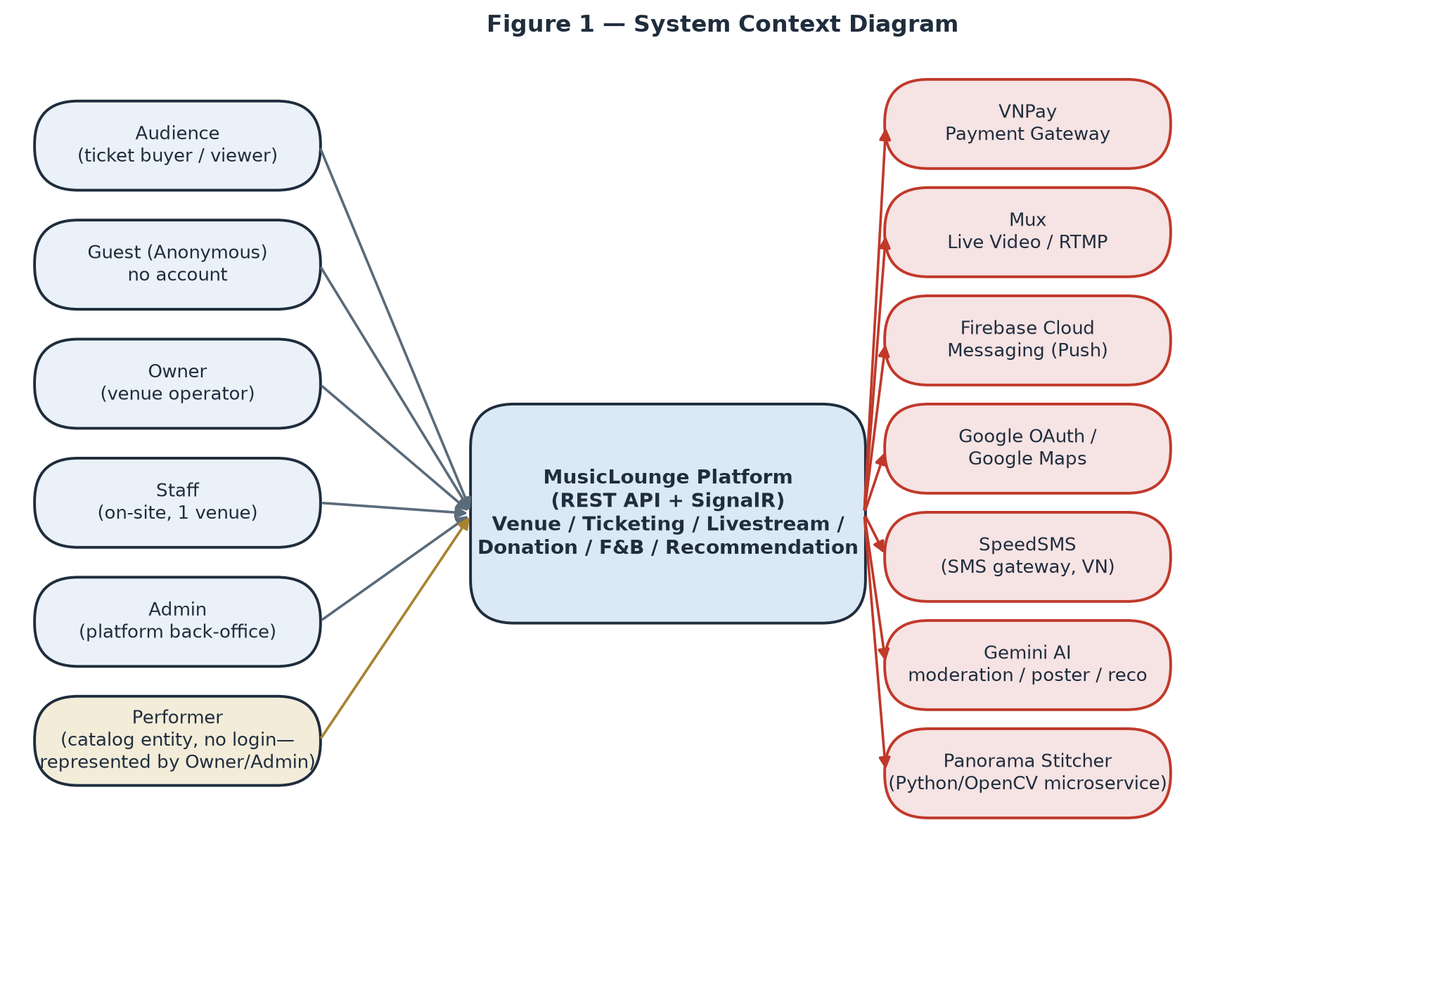
Figure 1 — System Context Diagram: human/business actors on the left, external systems on the right.

2. User Requirements

2.1 Actors
# | Actor | Description
1 | Guest (Anonymous) | A visitor with no account and no token. Can browse the public catalog (venues, shows, ticket tiers, seating layout, 360° tours, subscription-plan pricing), read the public donation transparency feed, and file/look up a complaint by reference number + phone — but cannot buy, donate, follow, wishlist, or rate anything (those require an authenticated account).
2 | Audience | A registered end-user who discovers shows, buys tickets (online or receives one as a walk-in sale from Staff), watches livestreams they hold a genuine ticket for, tips performers, rates attended shows, and manages their own account/privacy settings.
3 | Owner | Operates one or more venues: creates/edits the venue profile and seating layout, builds show line-ups and pricing, manages a subscription plan, registers bank accounts for payout, assigns Staff, handles donation acknowledgement/payout to performers, and tracks earnings. The single largest actor by screen count — almost half the system exists to serve this role.
4 | Staff | An Audience-role-adjacent worker assigned by exactly one Owner to exactly one venue at a time (never self-registered). Operates the floor during a show: sells walk-in tickets at the counter, scans QR codes at the door, and progresses F&B orders through the kitchen/bar workflow. Shares the livestream start/end controls with the Owner.
5 | Admin | The platform's internal back-office operator. There is deliberately no self-service or API path to become Admin — every Admin account today exists only via a direct database edit, and a background job (AdminRoleDriftDetectionJob) alerts if an Admin appears outside the known baseline, treating that as a possible compromise indicator. Approves venues, moderates show/livestream content, issues and reviews penalty appeals, processes refunds, verifies bank accounts, resolves complaints, and manages user accounts.
6 | Performer | A business entity, not a system actor with credentials — performers never log in. Every action on a Performer's behalf (profile edits, bank account registration, line-up assignment) is taken by the Owner who created that profile, or by Admin.
7 | VNPay (Payment Gateway) | An external system actor that calls back into MusicLounge to confirm the one transaction (ticket payment, donation, or subscription payment) it owns, via return-URL and IPN (Instant Payment Notification) callbacks. Holds no other privilege.
8 | Background Job Scheduler (Hangfire) | Runs entirely inside the process on a schedule, outside the HTTP request pipeline and outside any user identity — it has full internal write authority by design (auto-approving overdue appeals, releasing due settlements, reconciling VNPay, expiring holds, sending reminder emails/SMS/push) and cannot impersonate any human actor. See §3.1.8 for the full catalog of jobs.

2.2 Use Cases

2.2.1 Diagram(s)
Five actor-scoped use-case diagrams below group the 97 granular use cases listed in §2.2.2 into their functional areas — one diagram per primary actor.
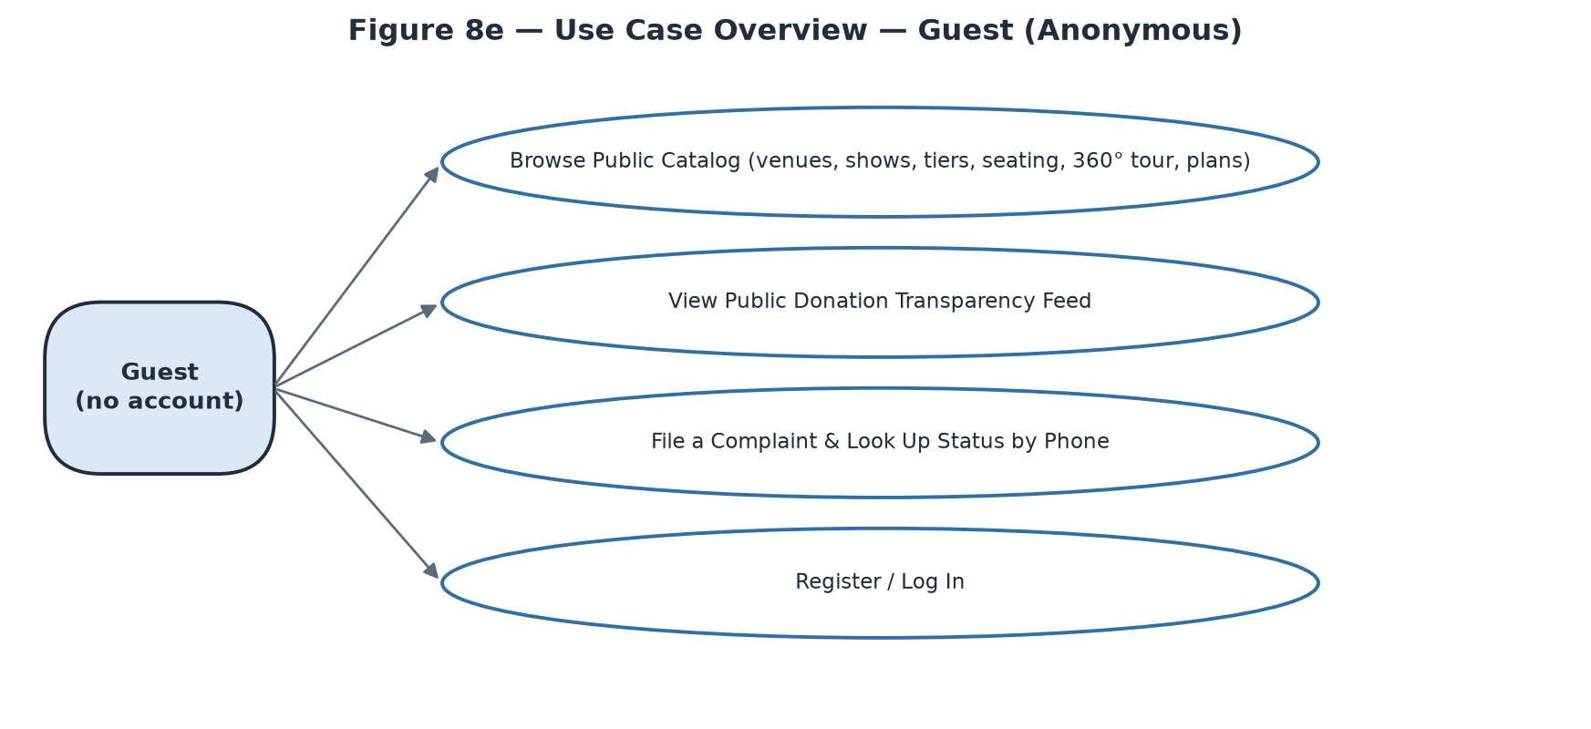
Figure 8a — Use Case Overview — Guest (Anonymous)
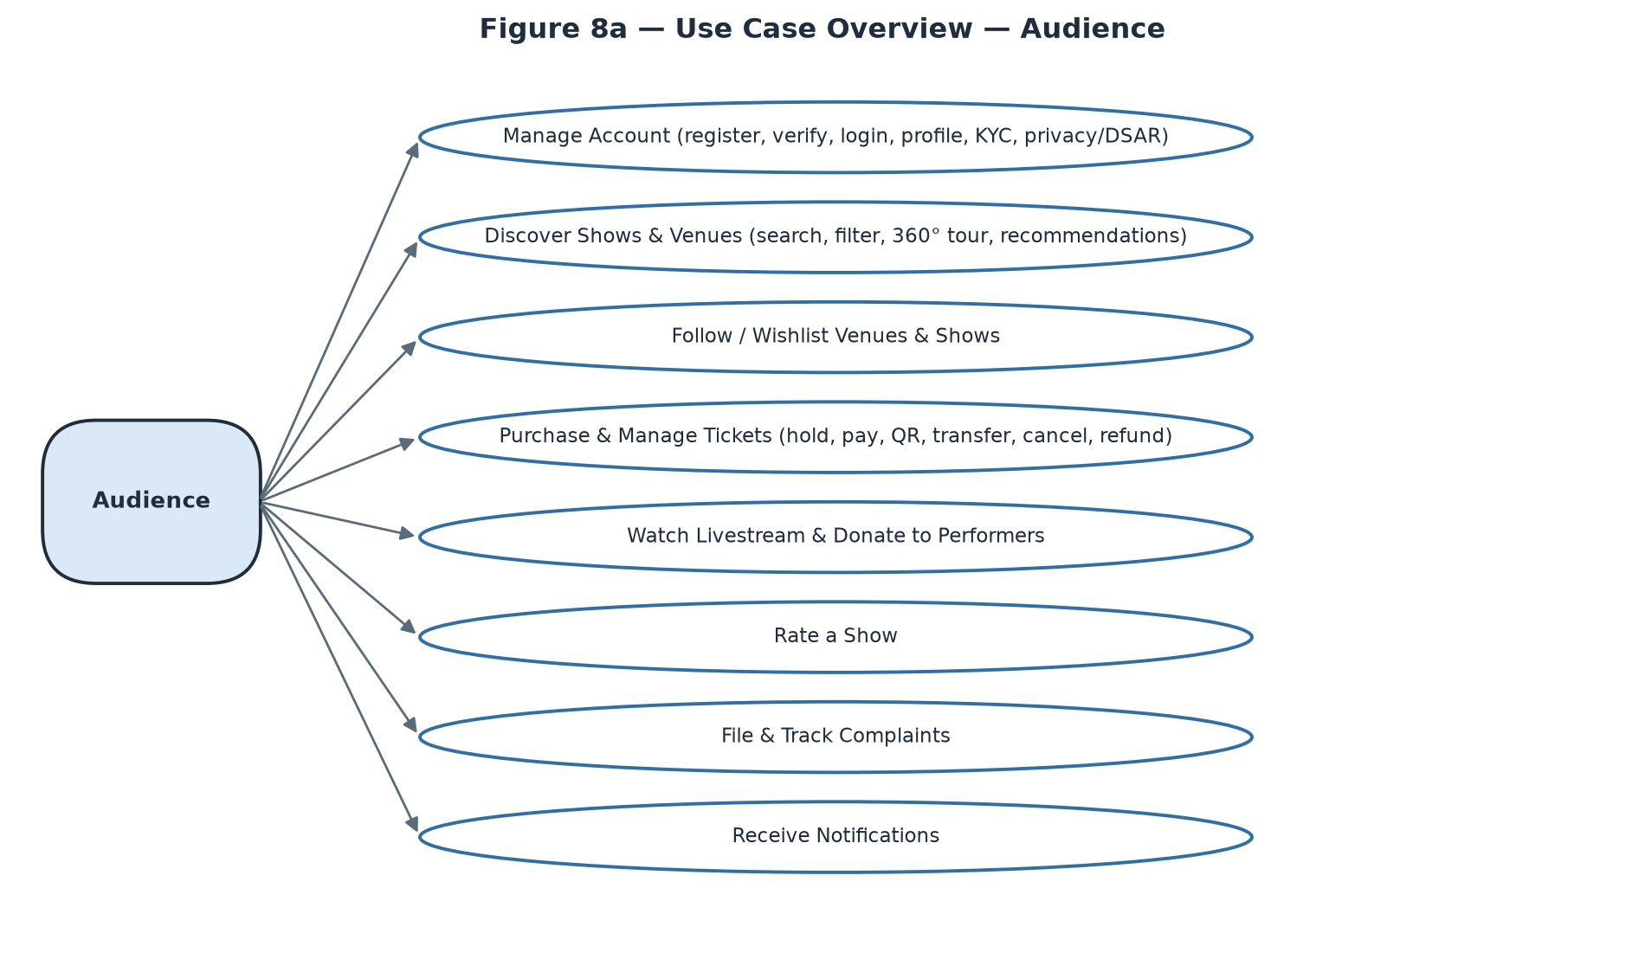
Figure 8b — Use Case Overview — Audience
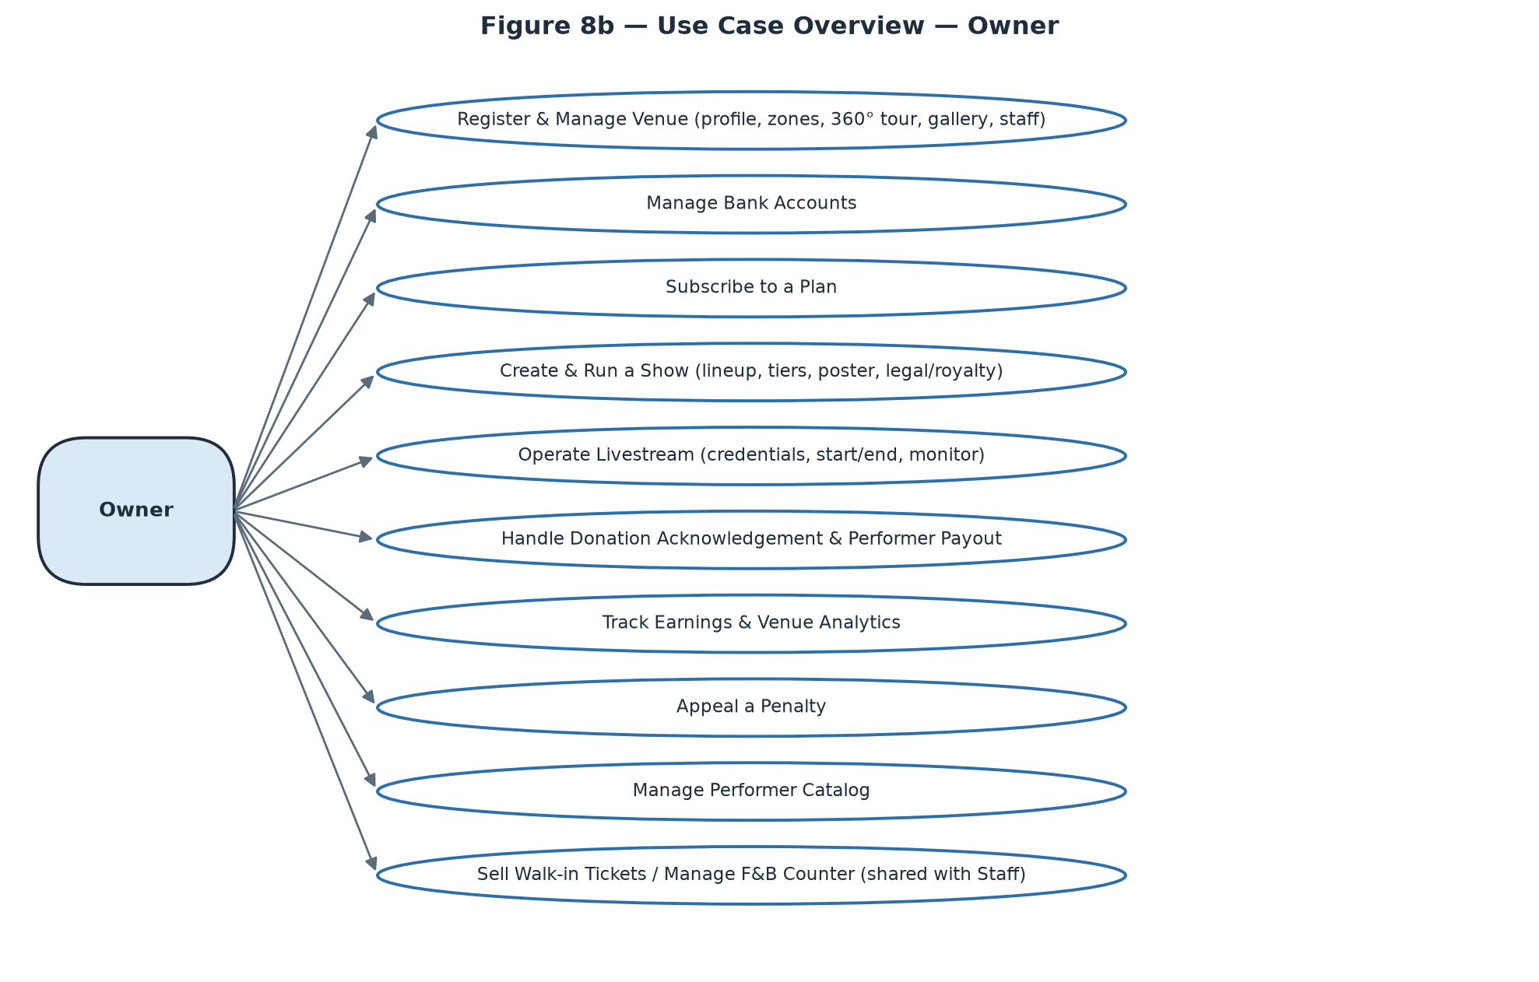
Figure 8c — Use Case Overview — Owner
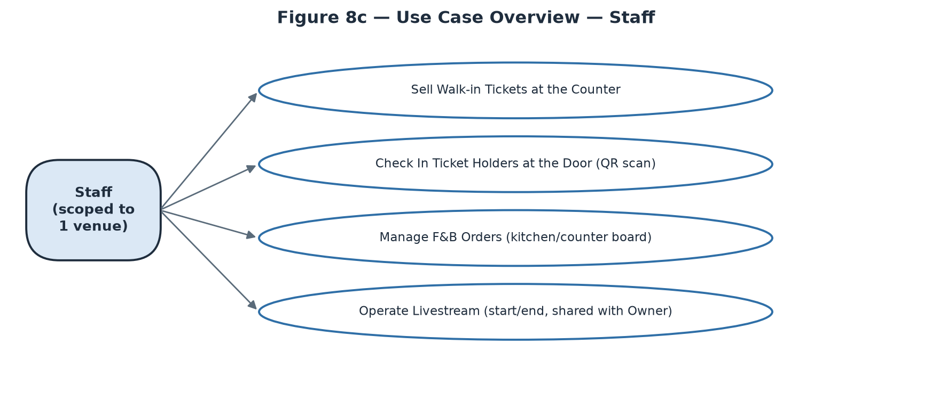
Figure 8d — Use Case Overview — Staff
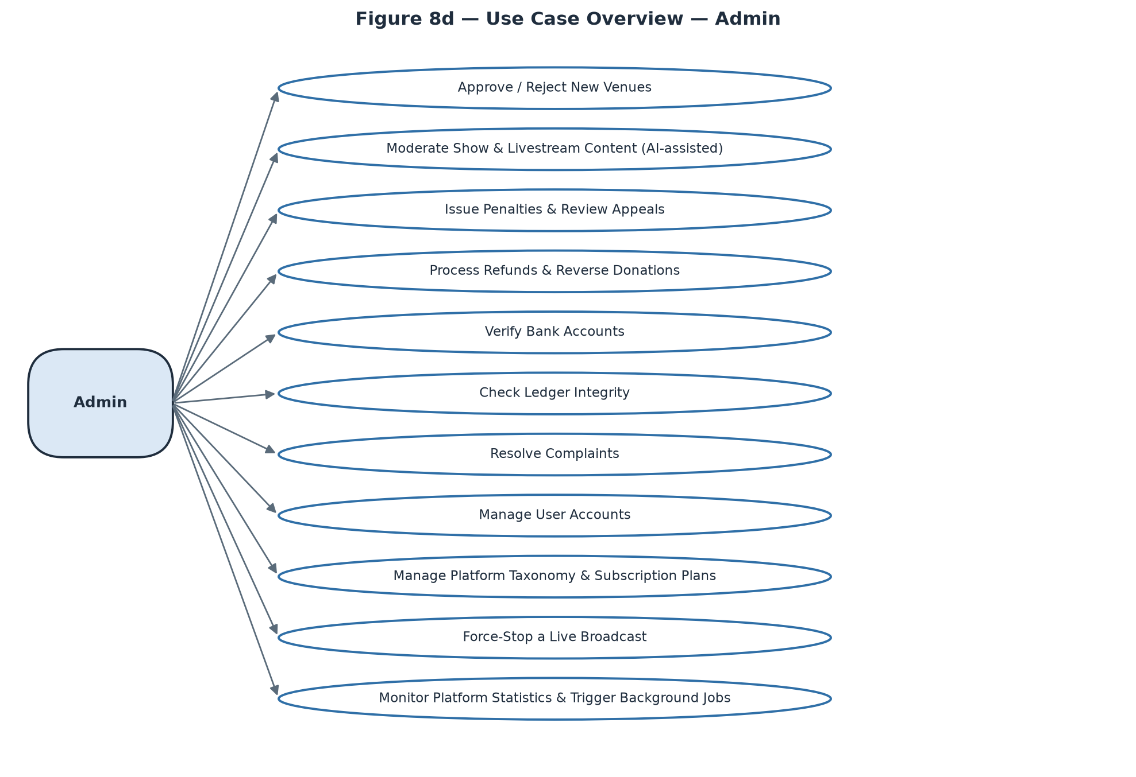
Figure 8e — Use Case Overview — Admin

2.2.2 Descriptions
ID | Use Case | Actors | Use Case Description
UC-01 | [Auth & Account] Register Account | Guest | Create an Audience or Owner account with email, password, full name and optional phone; account is not logged in until the email OTP is verified.
UC-02 | [Auth & Account] Verify Email | Guest | Enter the 6-digit OTP sent to the registered email to activate the new account.
UC-03 | [Auth & Account] Log In | Guest | Authenticate with email/password or Google OAuth. Returns a deliberately generic “Incorrect email or password” error for both wrong-email and wrong-password cases (anti user-enumeration).
UC-04 | [Auth & Account] Recover Password | Guest | Request a reset link by email (always shows a generic confirmation, never reveals whether the email is registered) and set a new password via the emailed one-time token.
UC-05 | [Auth & Account] Manage My Profile | Audience, Owner, Staff, Admin | View/edit name, phone, avatar, date of birth; change password (local accounts only — Google-linked accounts show “Linked to Google” instead).
UC-06 | [Auth & Account] Submit ID Verification | Audience, Owner, Staff, Admin | Upload front/back ID photos for optional identity verification.
UC-07 | [Auth & Account] Manage AI Recommendation Preferences | Audience, Owner, Staff, Admin | Set genre/mood/atmosphere taste tags and toggle personalised recommendations on/off (default opt-out per BVDLCN 2025 AI-consent rule).
UC-08 | [Auth & Account] Export My Data | Audience, Owner, Staff, Admin | Download a machine-readable export of the account's personal data (DSAR access right).
UC-09 | [Auth & Account] Deactivate My Account | Audience, Owner, Staff, Admin | Reversible self-service deactivation — blocks login until the user reactivates.
UC-10 | [Auth & Account] Erase My Data (DSAR) | Audience, Owner, Staff, Admin | Irreversible request to anonymise the account in place (never a hard delete, to preserve 10-year accounting-law retention on linked financial records) — requires re-entering the current password (local accounts) and immediately revokes every active JWT.
UC-11 | [Discovery] Search / Browse Shows | Guest, Audience | Full-text search and filter (genre, mood, date, price, format) across published shows.
UC-12 | [Discovery] View Show Detail | Guest, Audience, Owner | View full show information; action buttons are conditional — Buy Tickets (on-sale + seats remain), Watch Live (genuine ticket holder + show Ongoing), Rate (attended, ended ≤ 7 days, not yet rated), or a link to Show Control Center for the owning Owner.
UC-13 | [Discovery] Browse / Search Venues | Guest, Owner | List published venues; an Owner passing mine=true additionally sees their own Pending/Rejected venues.
UC-14 | [Discovery] View Venue Detail | Guest, Owner | View venue photos, address, atmosphere tags, upcoming shows, and seating-zone overview.
UC-15 | [Discovery] Explore 360° Virtual Tour | Guest, Audience | Drag-to-look-around panorama tour of a venue with clickable hotspots between scenes.
UC-16 | [Discovery] View Personalised Recommendations (“For You”) | Audience | Curated show feed; silently falls back to a generic “Trending” feed if personalisation is off or the account is too new for a signal.
UC-17 | [Discovery] View Performer Public Page | Guest, Audience | View a performer's bio, genre tags, upcoming/past shows, and link to their donation history.
UC-18 | [Discovery] View Subscription Plan Pricing | Guest, Audience, Owner | Publicly viewable plan comparison (price, ticket cap, AI-poster inclusion, tour-scene cap).
UC-19 | [Following] Follow / Unfollow a Venue | Audience | Toggle following a venue.
UC-20 | [Following] Wishlist / Remove a Show | Audience | Save or remove a show of interest.
UC-21 | [Following] View Following & Wishlist | Audience | Two-tab list (Venues / Shows) of everything followed/wishlisted.
UC-22 | [Ticket Purchase] Hold a Ticket | Audience | Reserve a tier/quantity for 15 minutes (configurable) before payment; a running countdown is a first-class UI element, not decorative.
UC-23 | [Ticket Purchase] Release a Ticket Hold | Audience | Cancel an active hold early.
UC-24 | [Ticket Purchase] Pay for a Held Ticket | Audience | Redirect to VNPay to complete payment for a held ticket; returns to a 3-state Payment Result screen (Processing / Success / Failed).
UC-25 | [Ticket Purchase] View My Tickets | Audience | Full ticket history across all statuses, upcoming separated from past.
UC-26 | [Ticket Purchase] View Ticket Detail / QR | Audience | View the entry QR code and seat/tier info; QR is hidden once Used/Cancelled/Refunded, replaced with a status label.
UC-27 | [Ticket Purchase] Transfer a Ticket | Audience | Transfer a Confirmed, not-yet-checked-in, never-streamed ticket to another Audience account.
UC-28 | [Ticket Purchase] Cancel a Ticket | Audience | Cancel a pending ticket freely, or a confirmed ticket within the show's own cancellation deadline/policy.
UC-29 | [Ticket Purchase] Track My Refund Requests | Audience | View refund status (pending/approved/rejected) after cancelling a ticket.
UC-30 | [Live & Donate] Watch a Livestream | Audience, Owner, Staff, Admin | Join the live viewing room subject to LivestreamAccessPolicy — genuine ticket holder within the concurrent-device limit (Audience), assigned venue operator (Owner/Staff), or unconditional access (Admin).
UC-31 | [Live & Donate] Send Live Chat Message | Audience, Owner, Staff, Admin | Post a chat message visible to everyone in the viewing room.
UC-32 | [Live & Donate] Donate to a Performer | Audience | Send a tip to one performer in the current line-up who has donations enabled for this set, with optional anonymity / amount-hiding / message-publishing toggles.
UC-33 | [Live & Donate] View My Donations | Audience | Track sent donations through a 3-step pipeline (Sent → Venue confirmed → Performer paid).
UC-34 | [Live & Donate] View Public Donation Ticker | Guest, Audience | Live, Twitch/Streamlabs-style alert feed for a specific show — no ticket or account needed.
UC-35 | [Live & Donate] View Public Donation Transparency Feed | Guest, Audience | Browse the settled (non-pending) platform-wide or per-performer donation ledger.
UC-36 | [Rating] Rate a Show | Audience | Submit a star rating + comment once per attended, ended show, within the review window.
UC-37 | [Complaints] File a Complaint | Guest, Audience | Report a problem against a ticket/show/venue/donation with category, description and optional evidence; guests must supply a phone number and are shown a reference number to save for later lookup.
UC-38 | [Complaints] Look Up a Guest Complaint | Guest | Check status using the reference number + the phone number supplied at filing.
UC-39 | [Complaints] View My Complaints | Audience, Owner, Staff, Admin | List filed complaints with status and, once resolved, the Admin's resolution notes.
UC-40 | [Notifications] View Notifications | Audience, Owner, Staff, Admin | Central inbox with unread badge and deep-link routing to the relevant screen; Admin additionally receives internal security/operations alerts no other role sees.
UC-41 | [Venue Setup] Register a Bank Account | Owner | Register a payout account for the venue itself or for a Performer the Owner manages; stays “Pending admin verification” until Admin verifies it — a real blocker on settlement and donation payout, not decorative.
UC-42 | [Venue Setup] Create a Venue | Owner | Submit venue profile, photos, business license, optional .glb 3D model; starts life at Pending, blocked from creating shows until Admin approval.
UC-43 | [Venue Setup] Edit a Venue | Owner | Edit an existing venue's profile fields.
UC-44 | [Venue Setup] Design Seating Zones | Owner | Drag-and-drop 2D/3D editor defining named zones and their real physical capacity — a hard, life-safety cap on ticket sales for that zone, reused across every show at the venue.
UC-45 | [Venue Setup] Build the 360° Virtual Tour | Owner | Upload a single pre-stitched panorama, or submit several room photos to the Python stitching microservice (Auto-Stitch, an async background job); place scenes on a floor-plan mini-map and add navigate/info hotspots between them. Scene count is capped by the subscription plan's MaxTourScenes.
UC-46 | [Venue Setup] Manage Venue Gallery & Custom Criteria | Owner | Maintain a showcase photo gallery (no subscription cap) and define venue-specific recommendation criteria tags that Audience members can express interest in.
UC-47 | [Venue Setup] Assign / Remove Staff | Owner | Look up a user by email, confirm eligibility (not already Owner/Admin/Staff-elsewhere), then assign as Staff for the venue; removal takes effect at the next login.
UC-48 | [Subscription] Subscribe to a Plan | Owner | Start checkout for a plan; blocked while an active plan already exists (cancel first).
UC-49 | [Subscription] Renew My Subscription | Owner | Extend the current plan via a fresh one-time VNPay payment (never auto-charged).
UC-50 | [Subscription] Cancel My Subscription | Owner | Cancel the active subscription.
UC-51 | [Show Management] Create a Show | Owner | Set name, description, format (in-person/livestream/hybrid), schedule, genre tags, ticket quota split, and build the performer line-up (typing an unmatched performer name silently creates a new catalog profile on submit).
UC-52 | [Show Management] Edit a Draft Show | Owner | Edit a show while still in Draft.
UC-53 | [Show Management] Submit a Show for Review | Owner | Requires an approved venue and at least one ticket tier; moves the show to Pending.
UC-54 | [Show Management] Reschedule a Show | Owner | Change the date/time of a Published, not-yet-ongoing show.
UC-55 | [Show Management] Change Show Format | Owner | In-person → online is one-way and automatically refunds 100% of confirmed in-person tickets — requires strong confirmation.
UC-56 | [Show Management] Change Playback Mode | Owner | Toggle 2D/3D for an online/hybrid show.
UC-57 | [Show Management] Cancel a Show | Owner | Refunds 100% of confirmed tickets; blocked while a livestream is actively broadcasting (must be terminated first).
UC-58 | [Show Management] Start / End an In-Person Show | Owner, Staff | Manual lifecycle buttons — hidden entirely (not just disabled) once a livestream is attached, which uses its own Start/End pair instead.
UC-59 | [Show Management] Manage Ticket Tiers | Owner | Add/edit/delete tiers (name, access type, zone, capacity, price) while the show is a Draft; total capacity is capped by the subscription plan's per-event ticket limit.
UC-60 | [Show Management] Generate / Upload a Show Poster | Owner | AI-generate a poster (subject to plan inclusion + monthly/per-show quota, async job with failure reason) or upload one directly; separate cover-image upload.
UC-61 | [Show Management] Declare Legal & Royalty References | Owner | Save the performance-permit reference and VCPMC music-royalty reference required before a livestream can start.
UC-62 | [Show Management] Manage the F&B Menu | Owner | Create/edit menu items (category, price, availability) for the venue.
UC-63 | [Livestream Ops] Create a Livestream | Owner, Staff | Provision RTMP URL + Stream Key for a show (kept hidden behind a reveal action — never shown to Audience).
UC-64 | [Livestream Ops] Start Broadcasting | Owner, Staff | Blocked until both the livestream-specific admin content review clears and the legal royalty reference is filled in — shown as two distinct missing-condition indicators.
UC-65 | [Livestream Ops] End Broadcasting | Owner, Staff | Manually end a live broadcast.
UC-66 | [Livestream Ops] Monitor Live Chat & Viewer Count | Owner, Staff, Admin | Viewer count is a manual-refresh figure, not a live-updating counter.
UC-67 | [Donation Handling] Acknowledge Donation Receipt | Owner | Confirm a VNPay-confirmed tip has arrived within a 24-hour window; auto-confirms on the Owner's behalf if the window lapses, with the two paths kept visually distinct.
UC-68 | [Donation Handling] Mark a Donation as Paid Out | Owner | Record that the performer's share has been manually wired, attaching a reference and proof photo; blocked (with a link to fix it) if the performer has no default bank account.
UC-69 | [Finance] View Earnings Overview | Owner | Cross-venue summary of settlements, ticket payments and donations; money held up by an unverified bank account is shown as “on hold”, never silently absent.
UC-70 | [Finance] View Venue Analytics | Owner | Per-venue performance metrics, with a venue picker for multi-venue Owners.
UC-71 | [Penalties & Appeals] Appeal a Penalty | Owner | File a written appeal against an Active penalty; view the venue's real combined restriction state (an overturned penalty does not auto-clear other overlapping ones).
UC-72 | [Performer Catalog] Create a Performer Profile | Owner | Add a performer to the platform-wide shared catalog (name, avatar, bio, type, genres).
UC-73 | [Performer Catalog] Edit / Delete a Performer Profile | Owner, Admin | Restricted to the profile's creator or Admin; delete is disabled (with reason) if the performer has ever been booked into any show.
UC-74 | [Performer Catalog] Manage Performer Social Links | Owner | Upsert social-platform links (Spotify/YouTube/SoundCloud/Facebook/Instagram) per performer.
UC-75 | [Counter Operations] Sell a Walk-in Ticket | Staff, Owner | One-step cash sale of an in-person-tier ticket with no buyer account; confirms immediately, no VNPay redirect, earns no platform commission by default.
UC-76 | [Counter Operations] Check In a Ticket at the Door | Staff, Owner | Scan a QR code, preview holder/tier before committing, then confirm; each rejection reason (already used, wrong show, online-only ticket, mid-transfer) is shown distinctly, with no offline fallback.
UC-77 | [F&B Operations] Take an F&B Order for a Table | Staff, Owner | Place an order on a customer's behalf, identical in effect to a self-service order.
UC-78 | [F&B Operations] Advance an F&B Order's Status | Staff, Owner | Move an order through the fixed sequence Pending → Preparing → Served → Paid, or Cancel at any point before Paid; marking Paid is a status flag only, not a payment reconciliation.
UC-79 | [F&B Ordering (Guest)] Browse F&B Menu & Order | Audience | Browse the venue's active menu (grouped by category) and place an order while physically at the venue; unavailable items are shown greyed-out, not hidden.
UC-80 | [F&B Ordering (Guest)] Track My F&B Order | Audience | View the current order's status stepper; not push-updated — requires a manual pull-to-refresh.
UC-81 | [Admin Approvals] Approve / Reject a New Venue | Admin | Review a Pending venue's submitted details and approve or reject (with a reason).
UC-82 | [Admin Approvals] Moderate Show / Livestream Content | Admin | Review an AI risk-scored submission (advisory only, full Admin discretion); a written note is required on rejection. Approving a show makes it public immediately; approving a livestream unlocks its Start Broadcasting control.
UC-83 | [Admin Penalties] Issue a Venue Penalty | Admin | Record Warning/Suspension/Ban with reason, evidence reference, and (for Suspension) a length.
UC-84 | [Admin Penalties] Review a Penalty Appeal | Admin | Uphold or overturn an Owner's appeal with a review note; no list view exists for open appeals today — reached only via a known penalty id (typically from a notification).
UC-85 | [Admin Finance] Approve / Reject a Refund Request | Admin | Full or partial approval (defaults to the full requested amount); reverses internal ledger entries only — does not call a live VNPay refund API in this environment.
UC-86 | [Admin Finance] Create a Manual Refund Request | Admin | Escape hatch for edge cases with no automatically generated request; still flows through the same approval queue.
UC-87 | [Admin Finance] Reverse a Donation | Admin | Reverse a specific donation's ledger entries by id, with a reason; refused once the performer has already been paid out. No queue exists — reached by id search, typically from a Complaint resolution.
UC-88 | [Admin Finance] Verify a Bank Account | Admin | Manually confirm a registered bank account by id after reconciling off-system; immediately unblocks any settlement waiting on it. No pending-verification list exists today.
UC-89 | [Admin Finance] Run the Ledger Integrity Check | Admin | Read-only diagnostic scanning for unbalanced accounting entries; an empty result is the good outcome and is shown distinctly from a loading/error state.
UC-90 | [Admin Complaints] Resolve a Complaint | Admin | Set status, resolution note and action type; refund/compensate against a ticket auto-creates a refund request, against a donation requires a separate manual reversal, take-down-content cancels the show and refunds all confirmed tickets. Guest complainants are notified by SMS, never in-app.
UC-91 | [Admin Users] Search & Inspect a User | Admin | Search/filter accounts by name, email, role, status; view submitted ID-verification photos through a protected (non-guessable) endpoint.
UC-92 | [Admin Users] Deactivate / Reactivate a User | Admin | Toggle account access; exactly one of the two actions is offered at a time based on current status.
UC-93 | [Platform Settings] Manage Taxonomy | Admin | Create category/genre/mood/atmosphere tags used platform-wide; creation only — no edit/delete exists today, a confirmed backend gap.
UC-94 | [Platform Settings] Manage Subscription Plans | Admin | Create/edit plans including an active/inactive toggle; edits never retroactively change terms for owners already subscribed under the old plan.
UC-95 | [Livestream Enforcement] Force-Stop a Livestream | Admin | Immediately terminate a broadcasting violation with a required reason; every viewer is disconnected instantly, shown distinctly from a normal Owner/Staff-initiated End.
UC-96 | [Monitoring] View Platform Statistics | Admin | System-wide analytics dashboard, distinct from a single venue's own Venue Analytics.
UC-97 | [Monitoring] Trigger a Background Job Manually | Admin | Run one job on demand from a fixed known list, for troubleshooting; a single immediate run only — does not alter that job's regular schedule, and returns no synchronous result.

3. Functional Requirements

3.1 System Functional Overview
The system is delivered as five separate client surfaces rather than one universal app — §3.1.1 summarises the split, §3.1.2–3.1.6 give the screens-flow diagram and screen catalog for each surface in turn, §3.1.7 consolidates role-based screen authorization across all five, §3.1.8 lists the non-screen (background job) functions, and §3.1.9 gives the entity catalog.

3.1.1 Client Surfaces & Roles
Backend (REST + SignalR) does not force any particular client — the 5-way split below is a documented product decision (platform-architecture.md), matched to how each actor actually works, not a technical limitation.
Surface | Primary Actor | Client Type | # Screens | Why
Audience — Website | Audience | Responsive website | 30 | Most concert-going is an in-person, occasional activity, not continuous app use — discovery/purchase/viewing/QR-at-the-door all work fine in a browser.
Audience — Mobile (F&B) | Audience | Native app (iOS/Android) | 2 | The one truly "phone in hand, at the table, right now" situation — in-venue food & drink ordering — kept deliberately narrow in scope.
Owner — Web Dashboard | Owner | Website (dashboard) | 27 | Desk work: multi-field forms, a drag-and-drop seating editor, financial dashboards.
Staff — Mobile | Staff | Native app/tablet | 7 | On-site, moving through the venue: counter sales, door check-in, kitchen/bar F&B board.
Admin — Web Console | Admin | Website (console) | 16 | Back-office: dense review queues, ledger reconciliation, user administration.
22 of the 75 catalogued screens (29.3%) are accessed by more than one actor; 3 of those have an explicit role-based difference in content or actions, called out in the Notes column (Live Viewing Room, Show Control Center, Performer Profiles), while the remaining 19 present identical content regardless of who is looking (e.g. Home / Show Search, Show Detail, Venue Detail, 360° Virtual Tour, Payment Result).

3.1.2 Audience — Website
Responsive website (desktop-primary, but the Ticket-Detail QR screen and Log In must also read well at phone width, since those two are the most likely to be opened on a phone at the door or on the go). Standard header navigation: Discover, My Tickets, Following, search bar, account menu. Covers domain groups A–F, H, I (30 screens) — everything an Audience member does except in-venue F&B ordering, which is the separate mobile app below.
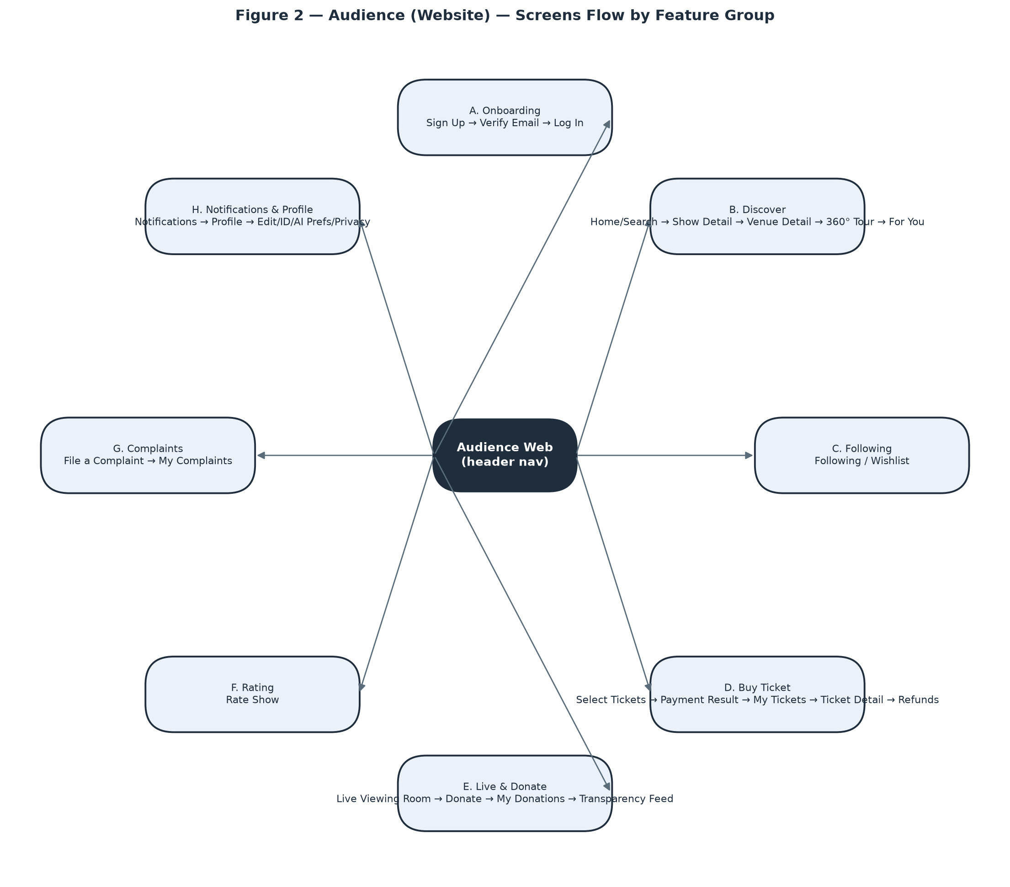
Screens Flow — Audience (Website).
# | Feature | Screen | Description
1 | Onboarding | Sign Up | Create an Audience/Owner account (email, password, name, optional phone); not logged in until email OTP verification.
2 | Onboarding | Verify Email | Enter the 6-digit OTP sent to the registered email to activate the account.
3 | Onboarding | Log In | Email/password or Google login; a single generic error covers both wrong-email and wrong-password.
4 | Onboarding | Forgot / Reset Password | Step 1 requests a reset email (always a generic confirmation); step 2, opened from the emailed link, sets a new password.
5 | Discover | Home / Show Search | Search and filter published shows by genre, mood, date, price, format; trending section and show-card grid.
6 | Discover | Show Detail | Full show info with conditional actions: Buy Tickets, Watch Live, Rate This Show, Follow/Wishlist — each gated on real eligibility, not just role.
7 | Discover | Venue Detail | Venue photos, address/map, atmosphere tags, upcoming shows, seating-zone overview, Follow toggle, link to the 360° tour if one exists.
8 | Discover | 360° Virtual Tour | Full-bleed drag-to-look-around panorama viewer with clickable hotspots between scenes.
9 | Discover | For You (Recommendations) | Personalised show feed; quietly becomes a generic Trending feed when personalisation is off or the account is new.
10 | Following | Following / Wishlist | Two tabs — Venues followed and Shows wishlisted — each with its own empty state.
11 | Buy Ticket | Select Tickets | Pick a tier + quantity and start a 15-minute hold (prominent countdown); sold-out tiers shown disabled with a reason.
12 | Buy Ticket | Payment Result | Shared 3-state template (Processing / Success / Failed) used for ticket, donation and subscription payments.
13 | Buy Ticket | My Tickets | Full ticket history, upcoming separated from past, across every status.
14 | Buy Ticket | Ticket Detail | Large entry QR code plus seat/tier info; conditional Transfer/Cancel actions; QR hidden once Used/Cancelled/Refunded.
15 | Buy Ticket | My Refund Requests | Status list (pending/approved/rejected) for cancelled tickets.
16 | Live & Donate | Live Viewing Room | Video player + chat + performer line-up for tipping, desktop-primary side-by-side layout; distinct messaging for access-rejected vs. a plain network hiccup.
17 | Live & Donate | Public Donation Ticker (widget) | Twitch/Streamlabs-style live alert feed embedded in Show Detail and the Live Viewing Room, visible with no ticket or account.
18 | Live & Donate | Donate (modal) | Tip a specific performer with optional anonymity/amount-hiding/message-publishing toggles, kept on top of the still-playing video.
19 | Live & Donate | My Donations | 3-step pipeline progress (Sent → Venue confirmed → Performer paid) per donation.
20 | Live & Donate | Public Donation Transparency Feed | Paginated public ledger — platform-wide with full fee breakdown, or per-performer amount-only — showing only settled donations.
21 | Live & Donate | Performer Public Page | Avatar, bio, genre tags, upcoming/past shows, link to the performer's transparency feed.
22 | Rating | Rate Show (modal) | Star rating + comment, reachable exactly once per attended show within the review window.
23 | Complaints | File a Complaint | Category, target, description, optional evidence; guests must also give a phone number and are shown a reference number to save.
24 | Complaints | My Complaints | Status list with full detail and Admin resolution notes once resolved.
25 | Notifications & Profile | Notifications | Central inbox with unread badge, deep-linking by notification type.
26 | Notifications & Profile | Profile | Account hub linking to Edit Profile, ID Verification, AI Preferences, Privacy & Data, My Donations, My Complaints.
27 | Notifications & Profile | Edit Profile | Name, phone, avatar, date of birth; change-password section hidden for Google-linked accounts.
28 | Notifications & Profile | ID Verification | Upload front/back ID photos; shows submission status.
29 | Notifications & Profile | AI Preferences | Genre/mood/atmosphere taste tags and a personalisation on/off toggle with a visible explanation of what turning it off changes.
30 | Notifications & Profile | Privacy & Data | Export My Data, Deactivate Account (reversible), Delete My Data (irreversible, two-step confirmation, signs out everywhere).

3.1.3 Audience — Mobile (F&B Ordering)
A deliberately narrow native mobile app (iOS/Android), used only while physically at a venue watching a show. No browsing, tickets, livestream or donations here — those live on the website above. Covers domain group G (2 screens).
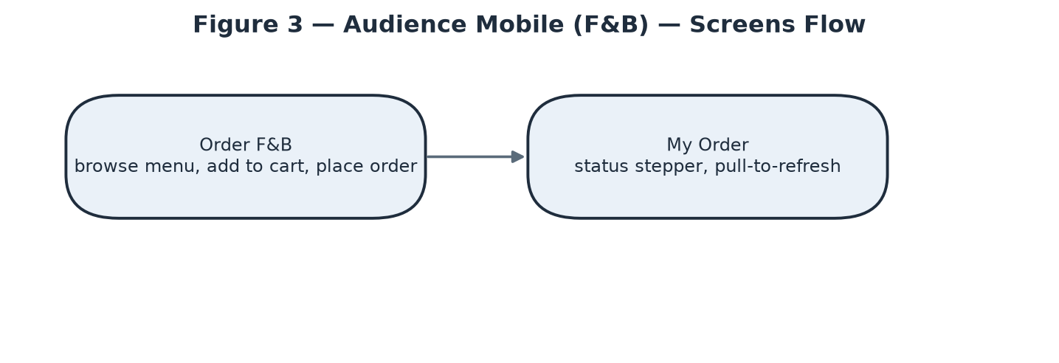
Screens Flow — Audience — Mobile (F&B Ordering).
# | Feature | Screen | Description
1 | F&B Ordering | Order F&B | Browse the venue's active menu grouped by category, add to cart, place order; sold-out items shown greyed-out, not removed; venue/table context established once at session start.
2 | F&B Ordering | My Order | Status stepper (Pending → Preparing → Served → Paid, or Cancelled); not push-updated — a manual pull-to-refresh, since staff update status from a separate tool with no live channel to this app.

3.1.4 Owner — Web Dashboard
Desktop-primary business dashboard (sidebar navigation with a venue switcher for multi-venue Owners) — form-heavy setup flows, a drag-and-drop seating editor, and financial dashboards. Covers domain groups J–Q, AA plus the Owner-facing share of N and R (27 screens). 7 of those — Notifications, Profile, Edit Profile, ID Verification, AI Preferences, Privacy & Data, My Complaints — are the same shared account-management screens already listed once under Audience Web, not repeated here.
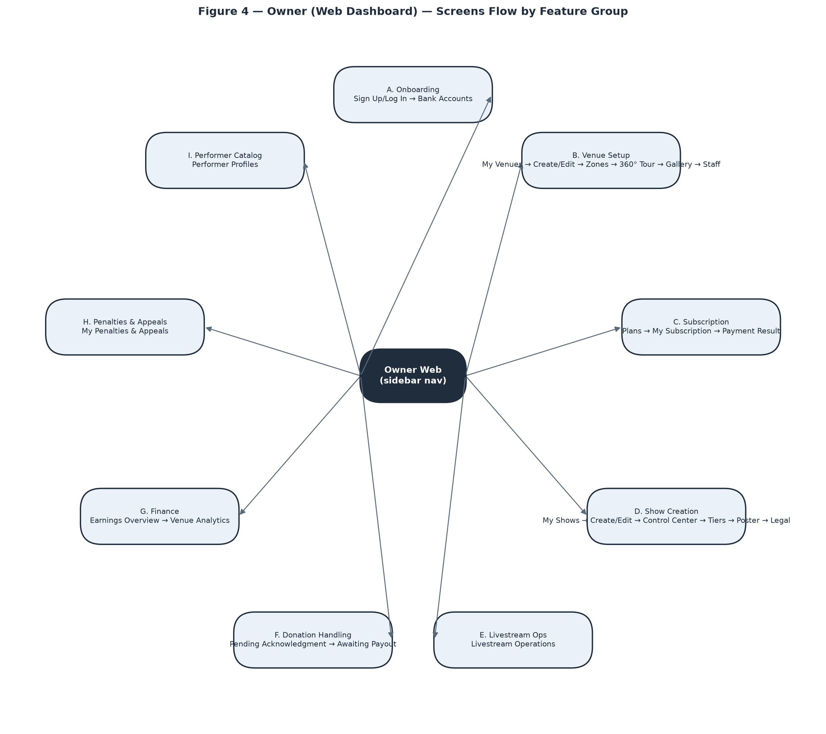
Screens Flow — Owner — Web Dashboard.
# | Feature | Screen | Description
1 | Onboarding | Sign Up / Log In / Password Recovery | Same account flows as Audience, skinned to the dashboard, registering with the Owner role.
2 | Onboarding | Bank Accounts | Register payout accounts for the venue and for performers the Owner manages; unverified accounts show a real “Pending admin verification” blocker on settlement/donation payout.
3 | Venue Setup | My Venues | Cards/rows per venue with status badge; Pending shows “waiting for admin approval” with all management disabled; Rejected shows the reason with no resubmit path.
4 | Venue Setup | Create / Edit Venue | Profile fields, photo/license upload, optional .glb 3D model (distinct from the 360° tour feature).
5 | Venue Setup | Seating Zone Editor | Drag-and-drop 2D/3D placement of named zones with a real physical capacity that hard-caps ticket sales for that zone.
6 | Venue Setup | 360° Virtual Tour (management) | Add a pre-made panorama or Auto-Stitch several room photos (async job, 15–30+s); place scenes on a mini-map with navigate/info hotspots; capped by subscription tier.
7 | Venue Setup | Venue Extras (Gallery & Custom Criteria) | Showcase photo gallery (no cap) plus venue-defined recommendation-criteria tags.
8 | Venue Setup | Staff Management | Look up a user by email, confirm eligibility, assign/remove as Staff for the venue.
9 | Subscription | Subscription Plans | Publicly viewable plan comparison; Choose Plan starts checkout for a logged-in Owner.
10 | Subscription | My Subscription | Current plan snapshot, Subscribe/Renew/Cancel; Renew still requires a real one-time payment.
11 | Subscription | Payment Result | Shared 3-state payment template; on success here, lands back on My Subscription.
12 | Show Management | My Shows | Every show at any stage (Draft/Pending/Published/Ongoing/Ended/Cancelled).
13 | Show Management | Create / Edit Show | Core details plus a line-up builder; typing an unmatched performer name silently creates a new profile on submit.
14 | Show Management | Show Control Center | Lifecycle hub — Submit for Review, Reschedule, Change Format, Change Playback Mode, Cancel, Start/End — with links out to Tiers, Poster, Legal, Livestream Ops.
15 | Show Management | Ticket Tiers | Add/edit/delete tiers while Draft, capped by the plan's per-event ticket limit; a running “X of Y tickets used” indicator.
16 | Show Management | Poster | AI-generate (plan-gated, async, quota-limited) or upload a poster; separate cover-image upload.
17 | Show Management | Legal & Royalty Declaration | Performance-permit and VCPMC royalty reference fields required before a livestream can start.
18 | Livestream Ops | Livestream Operations | RTMP URL + Stream Key (hidden by default), Start/End Broadcasting (blocked on two independent conditions shown distinctly), live chat/viewer monitor (manual-refresh).
19 | Donation Handling | Pending Acknowledgment | Countdown-to-24h list of tips awaiting Owner confirmation; auto-confirms on timeout, tracked distinctly from a manual confirm.
20 | Donation Handling | Awaiting Payout | Mark a donation Paid with a reference + transfer-proof photo; blocked if the performer has no default bank account.
21 | Finance | Earnings Overview | Cross-venue summary of settlements, ticket payments and donations; money on hold is shown as such, never silently absent.
22 | Finance | Venue Analytics | Per-venue performance metrics with a venue picker.
23 | Penalties & Appeals | My Penalties & Appeals | Penalty history and appeal filing; shows the venue's real combined restriction state, not one penalty in isolation.
24 | Performer Catalog | Performer Profiles | Searchable platform-wide catalog; Edit/Delete visible only to the creating Owner or Admin; Delete disabled if ever booked.
25 | F&B Menu | Manage F&B Menu | Create/edit menu items (category, price, availability) for the venue.
26 | Counter Ops (shared with Staff) | Walk-In Sale | Sell an in-person ticket for cash at the counter; same screen as Staff uses.
27 | Counter Ops (shared with Staff) | Manage F&B Orders at Counter | Same order board as Staff, same RequireVenueOperator access.

3.1.5 Staff — Mobile
Native mobile/tablet app used standing up, on the floor, during show hours — bottom tab bar (Sell / Check-In / F&B), large tap targets, minimal typing, no venue switcher (a Staff session is scoped to exactly one venue for the whole shift). Covers domain group S plus the Staff-facing share of M and N (7 screens).
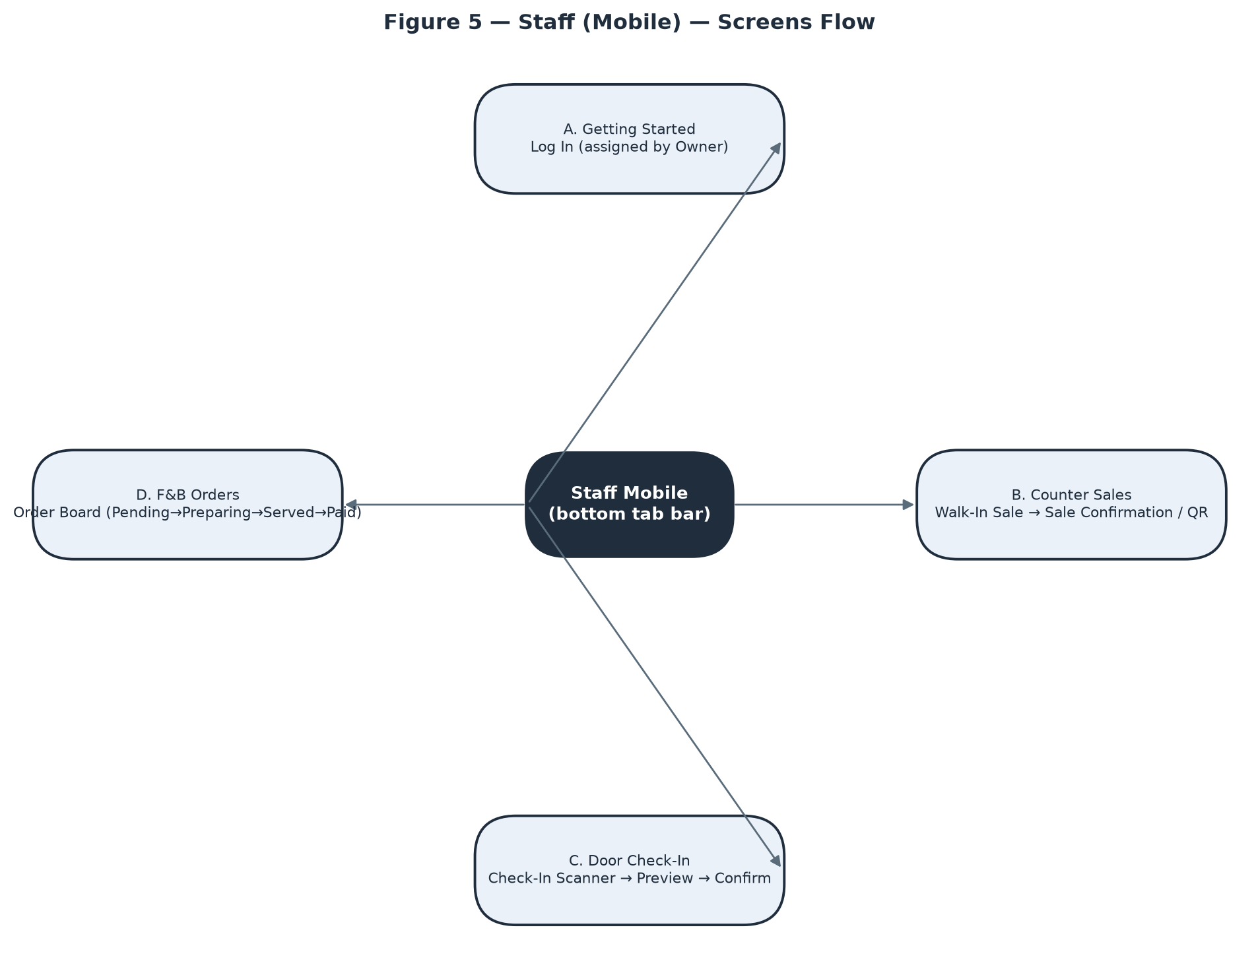
Screens Flow — Staff — Mobile.
# | Feature | Screen | Description
1 | Getting Started | Log In | Same login as Audience/Owner; access exists only after an Owner assigns the Staff role — revocation surfaces as a clear “no longer have access to this venue” state, not a crash.
2 | Counter Sales | Walk-In Sale | Sell an in-person ticket tier for cash, one step, no external payment redirect; earns no commission by default so none is shown on the receipt.
3 | Counter Sales | Sale Confirmation / QR | Large QR handed to a buyer with no account of their own — screenshot-friendly, no email step.
4 | Door Check-In | Check-In Scanner | Camera scan → preview (holder, tier) → explicit Confirm; each rejection reason (already used, wrong show, online-only ticket, mid-transfer) shown distinctly; no offline fallback, connection state always visible.
5 | F&B Orders | Order Board | Orders grouped by status; exactly one “next step” button per order following the fixed Pending→Preparing→Served→Paid sequence; Cancel available up to Paid; marking Paid is a status flag only.
6 | Shared with Owner | Livestream Operations | Identical screen/controls to the Owner dashboard's Livestream Ops — RTMP credentials, start/end, chat/viewer monitor.
7 | Shared with Owner | Show Control Center (Start/End only) | Staff sees only the Start/End buttons; every Owner-only action (Submit for Review, Reschedule, Change Format, Cancel) is hidden, not merely disabled.

3.1.6 Admin — Web Console
Desktop-only back-office console, no exceptions — dense data tables, multi-field review forms, cross-referencing several data sources at once. No self-service signup; every Admin account is provisioned by direct database edit as a deliberate security posture. Covers domain groups T–Z plus the Admin-facing share of F and R (16 screens).
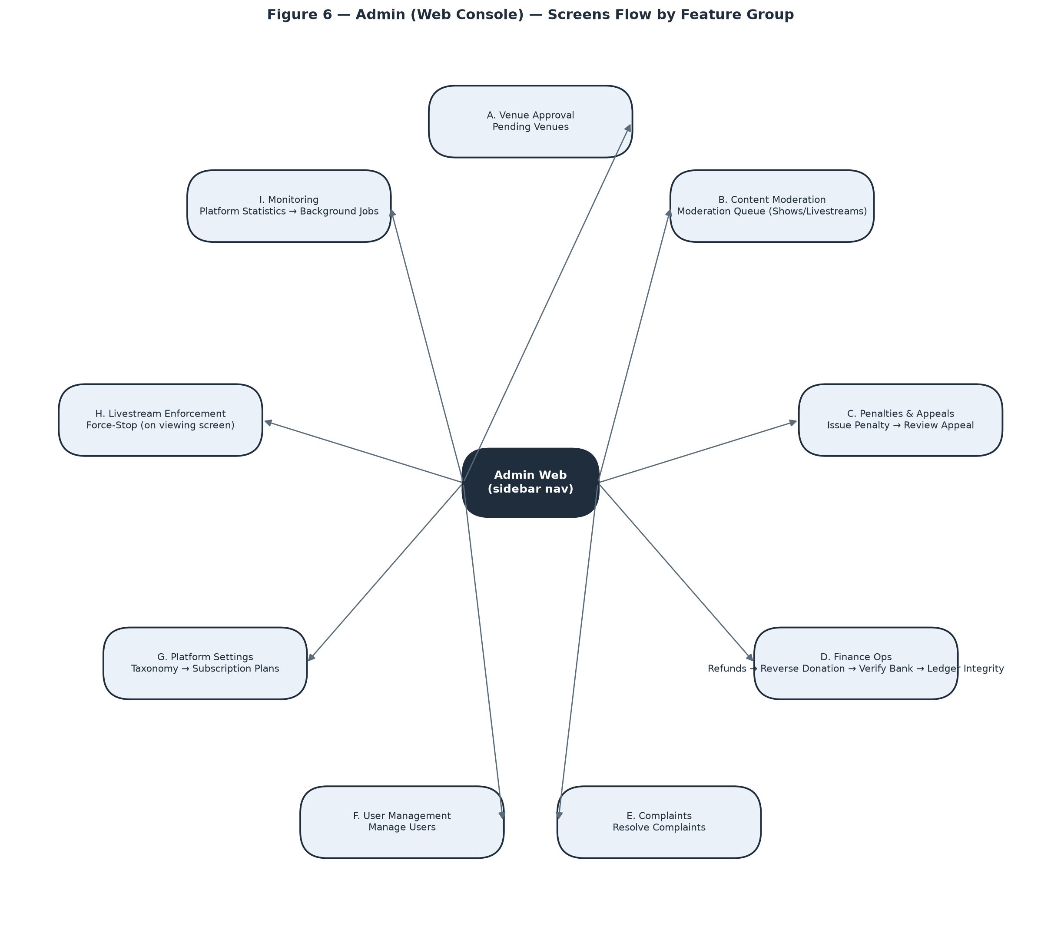
Screens Flow — Admin — Web Console.
# | Feature | Screen | Description
1 | Venue Approval | Pending Venues | Approve/reject queue for newly registered venues; every item immediately actionable, no conditional gating.
2 | Content Moderation | Moderation Queue | Tabbed Shows/Livestreams queue with an AI risk score shown as a suggestion only, full Admin discretion; a note is required on rejection.
3 | Penalties & Appeals | Issue Penalty | Target venue, level (Warning/Suspension/Ban), reason, evidence reference, suspension length when applicable.
4 | Penalties & Appeals | Review Appeal | Overturn or uphold with a review note; reached only via a known penalty id — no “all open appeals” list exists today, a confirmed backend gap.
5 | Finance Ops | Refund Requests | Queue spanning three origins (self-cancel, show-cancel, complaint resolution); approve full/partial or reject; internal ledger reversal only, no live gateway refund call in this environment.
6 | Finance Ops | Reverse a Donation | Stand-alone id-search action, no queue; refused once the performer has already been paid out.
7 | Finance Ops | Verify Bank Account | Stand-alone id-entry action with no pending-verification list anywhere in the backend today — the single screen in the whole console with no natural entry point.
8 | Finance Ops | Ledger Integrity Check | Read-only diagnostic; an empty result (the good outcome) is shown distinctly from loading/error states.
9 | Complaints | Resolve Complaints | Queue across ticket/show/venue/donation/penalty targets; the automation triggered varies by resolution-action type and is made explicit per combination; guest complainants notified by SMS only.
10 | User Management | Manage Users | Searchable/filterable account list plus per-user detail incl. protected ID-verification photos; Deactivate/Reactivate shown one at a time based on current status.
11 | Platform Settings | Taxonomy Management | Create category/genre/mood/atmosphere tags; creation only — no edit/delete exists today, a confirmed backend gap.
12 | Platform Settings | Subscription Plan Management | Create/edit plans incl. active/inactive toggle; edits never retroactively affect already-subscribed owners.
13 | Livestream Enforcement | Force-Stop a Livestream | An extra admin-only control on the shared Live Viewing screen (not a separate page); disconnects every viewer instantly.
14 | Monitoring | Platform Statistics | System-wide analytics, a completely separate screen from a single venue's own Venue Analytics.
15 | Monitoring | Background Jobs | Manually trigger one job on demand from a fixed list; a single immediate run, not a schedule editor; no synchronous result — check the job's own output surface afterward.
16 | Performer Catalog (shared with Owner) | Performer Profiles — Edit/Delete rights | Admin sees Edit/Delete on every performer profile platform-wide, where an Owner sees it only on profiles they created.

3.1.7 Screen Authorization
Consolidated matrix across all 5 surfaces (75 distinct screens — some names, e.g. Payment Result or Livestream Operations, are literally the same screen reused by more than one surface). See the Notes column for the handful of screens where two roles share access but not the same rights.
Screen | Anon. | Audience | Owner | Staff | Admin | Notes
Sign Up | X
Verify Email | X
Log In | X
Forgot / Reset Password | X
Home / Show Search | X | X | X
Show Detail | X | X | X
Venue Detail | X | X | X
360° Virtual Tour | X | X
For You (Recommendations) |  | X
Following / Wishlist |  | X
Select Tickets |  | X
Payment Result |  | X | X
My Tickets |  | X
Ticket Detail |  | X
My Refund Requests |  | X
Live Viewing Room |  | X | X | X | X | Audience: genuine ticket holder within device limit. Owner/Staff: assigned venue operator only. Admin: unconditional + exclusive Force-Stop control.
Public Donation Ticker (widget) | X | X
Donate (modal) |  | X
My Donations |  | X
Public Donation Transparency Feed | X | X
Performer Public Page | X | X
Rate Show (modal) |  | X
File a Complaint | X | X
My Complaints |  | X | X | X | X
Notifications |  | X | X | X | X
Profile |  | X | X | X | X
Edit Profile |  | X | X | X | X
ID Verification |  | X | X | X | X
AI Preferences |  | X | X | X | X
Privacy & Data |  | X | X | X | X
Order F&B |  | X
My Order |  | X
Bank Accounts |  |  | X
My Venues |  |  | X
Create / Edit Venue |  |  | X
Seating Zone Editor |  |  | X
360° Virtual Tour (management) |  |  | X
Venue Extras (Gallery & Custom Criteria) |  |  | X
Staff Management |  |  | X
Subscription Plans | X |  | X
My Subscription |  |  | X
My Shows |  |  | X
Create / Edit Show |  |  | X
Show Control Center |  |  | X | X |  | Owner: full (submit/reschedule/change-format/cancel/start/end). Staff: Start/End only — every other action hidden, not just disabled.
Ticket Tiers |  |  | X
Poster |  |  | X
Legal & Royalty Declaration |  |  | X
Livestream Operations |  |  | X | X
Pending Acknowledgment |  |  | X
Awaiting Payout |  |  | X
Earnings Overview |  |  | X
Venue Analytics |  |  | X
My Penalties & Appeals |  |  | X
Performer Profiles |  |  | X |  | X | Create/assign: any Owner. Edit/Delete: only the creating Owner, or Admin.
Manage F&B Menu |  |  | X
Walk-In Sale |  |  | X | X
Manage F&B Orders at Counter |  |  | X
Sale Confirmation / QR |  |  |  | X
Check-In Scanner |  |  |  | X
Order Board |  |  |  | X
Pending Venues |  |  |  |  | X
Moderation Queue |  |  |  |  | X
Issue Penalty |  |  |  |  | X
Review Appeal |  |  |  |  | X
Refund Requests |  |  |  |  | X
Reverse a Donation |  |  |  |  | X
Verify Bank Account |  |  |  |  | X
Ledger Integrity Check |  |  |  |  | X
Resolve Complaints |  |  |  |  | X
Manage Users |  |  |  |  | X
Taxonomy Management |  |  |  |  | X
Subscription Plan Management |  |  |  |  | X
Force-Stop a Livestream |  |  |  |  | X
Platform Statistics |  |  |  |  | X
Background Jobs |  |  |  |  | X

3.1.8 Non-Screen Functions
All 29 non-screen functions run as Hangfire background jobs, entirely outside the HTTP request pipeline and outside any user identity — see §4.2.2 (Reliability) for the SLA values several of these jobs enforce.
# | Feature | System Function | Description
1 | Ticket | Release Expired Holds | Recurring job — releases a ticket hold once its 15-minute (configurable) window has passed without payment, freeing the quota back to sale.
2 | Ticket | Expire Ticket Transfers | Recurring job — cancels a pending peer-to-peer ticket transfer that was never accepted within its window.
3 | Payment | Cancel Abandoned Payments | Recurring job — cancels a VNPay payment attempt that was started but never completed.
4 | Payment | Reconcile VNPay Payments | Recurring job — cross-checks local payment records against VNPay's own transaction records to catch silent drift.
5 | Finance | Release Due Settlements | Recurring job — releases each Settlement tranche (Partial70 / Final30) once its scheduled date arrives; routes a Final30 tranche to PendingReview instead of auto-release when the show's actual/expected duration ratio falls below the configured threshold (default 70%).
6 | Finance | Check Ledger Integrity | Recurring job — scans all LedgerEntry rows for any journal where debits and credits do not balance; feeds the Admin Ledger Integrity Check screen.
7 | Donation | Auto-Confirm Donations | Recurring job — auto-confirms a VNPay-paid donation into Owner-acknowledged status once the 24-hour acknowledgement window lapses without manual action.
8 | Donation | Check Overdue Donations | Recurring job — flags/notifies when a donation has sat unpaid-to-performer for 7 days, escalating to a venue penalty warning past 14 days.
9 | Donation | Expire Stuck Donations | Recurring job — cancels a donation payment attempt that never reached a terminal VNPay state.
10 | Subscription | Warn Expiring Subscriptions | Recurring job — sends an advance-warning notification before an Owner's active subscription expires.
11 | Subscription | Expire Subscriptions | Recurring job — transitions a subscription past its ExpiresAt to Expired.
12 | Venue | Apply Due Venue Penalties | Recurring job — applies a penalty's real effect (Suspended/Locked) once its EffectiveAt delay elapses.
13 | Venue | Auto-Approve Overdue Appeals | Recurring job — auto-overturns a penalty appeal that Admin has not reviewed within the 48-hour SLA.
14 | Moderation | Score Moderation with AI | Triggered job (enqueued on submission) — calls Gemini AI to produce a risk score and recommendation for a show/livestream/gallery-image/tour-scene moderation record.
15 | Moderation | Alert Moderation SLA Breaches | Recurring job — warns internally when a content-moderation review is approaching or has missed its 24-hour SLA (Decree 147/2024).
16 | Complaint | Alert Complaint SLA Breaches | Recurring job — same SLA-breach pattern applied to complaint resolution.
17 | Show | Send Event Reminders | Recurring job — sends a reminder notification ahead of an upcoming show to ticket holders / wishlisters.
18 | Recommendation | Log User Behaviour | Triggered job — records a single behaviour event (view/attend/rate/donate/wishlist) for the recommendation pipeline, skipped entirely when the user has not given AI consent.
19 | Recommendation | Recompute User Event Scores | Recurring job — aggregates raw behaviour logs into the User↔Show interest-score matrix.
20 | Recommendation | Refresh Recommendations | Recurring job — regenerates the platform-wide AiRecommendation feed from current scores.
21 | Recommendation | Refresh User Recommendation | Triggered job — regenerates one user's recommendation feed on demand (e.g. after an explicit preference change).
22 | Venue Tour | Stitch Venue Tour Scene | Triggered job — calls the external Python/OpenCV panorama-stitching microservice for an Auto-Stitch request and writes back the resulting scene or failure reason.
23 | Notification | Send Email Verification Code | Triggered job — sends the OTP email for account verification.
24 | Notification | Send Password Reset Email | Triggered job — sends the password-reset link email.
25 | Notification | Send Phone Verification Code | Triggered job — sends an SMS OTP via SpeedSMS for phone verification.
26 | Notification | Prune Stale Device Tokens | Recurring job — removes Firebase device tokens that have not been seen for an extended period.
27 | Notification | Alert Push Failures | Recurring job — raises an internal alert once FCM push failures cross a threshold, distinguishing a systemic push-delivery problem from one dead device.
28 | Security | Detect Login Spikes | Recurring job — scans recent login-failure logs for a credential-stuffing pattern across many accounts from one IP and alerts Admin.
29 | Security | Detect Admin Role Drift | Recurring job — compares the live set of Admin-role users against the known baseline snapshot and alerts if a new, unrecognised Admin has appeared (the only way to become Admin is a direct database edit, so this is treated as a compromise indicator).

3.1.9 Entity Relationship Diagram
68 entities in total. Figure 7 below shows only the central, cross-domain entities — the full catalog (68 entities across 56 rows below; a few closely-related join/preference tables are grouped per row for readability) follows in the table.
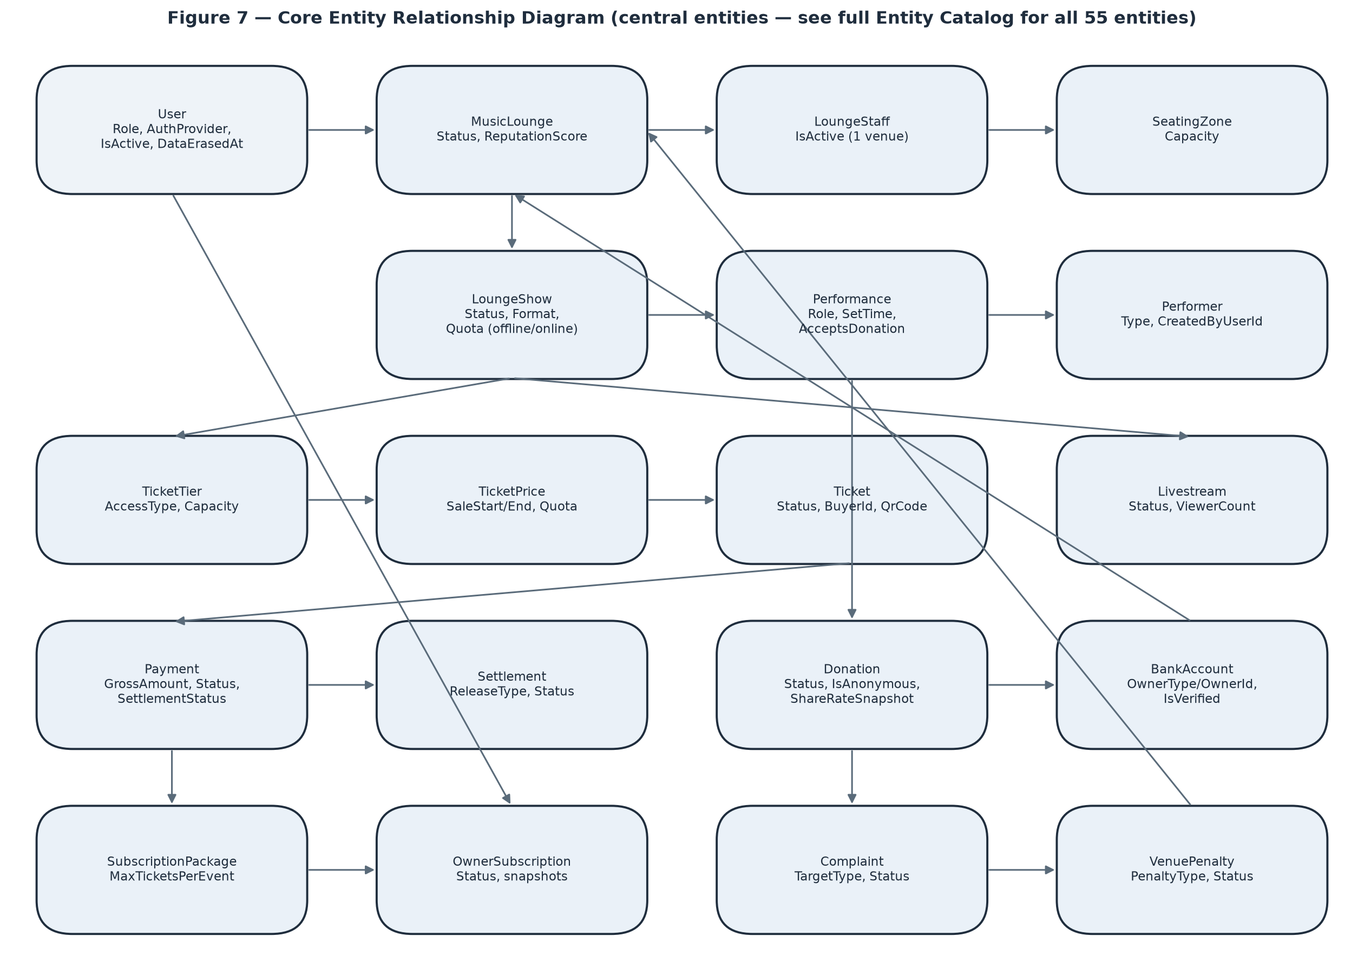
Figure 7 — Core Entity Relationship Diagram.
Entities Description
# | Entity | Description
1 | [Auth & User] User | Identity for every role (Audience/Staff/Owner/Admin); local or Google auth, DSAR erasure fields, brute-force lockout fields.
2 | [Venue] MusicLounge | A venue ("lounge"); state machine status, cached reputation score, optional 3D model, business license.
3 | [Venue] LoungeStaff | Assignment of one User as Staff to one venue; unique-active-per-user constraint.
4 | [Venue] SeatingZone | A named seating area with a real physical (fire-code) capacity, reused across a venue's shows.
5 | [Venue] VenueTourScene | One 360° panorama image — one stop in the virtual tour; flags AI-assisted completion for legal disclosure.
6 | [Venue] VenueTourHotspot | A clickable point inside a scene — navigates to another scene or shows an info popup.
7 | [Venue] VenueTourStitchAttempt | Log of one photo-stitching attempt (not just the final result), including the independent AI gap-fill outcome.
8 | [Venue] LoungeGalleryImage | One showcase photo for the venue's public gallery.
9 | [Venue] VenuePenalty | One penalty event against a venue; state machine incl. appeal fields.
10 | [Taxonomy] MusicGenre / Mood / VenueAtmosphere | Three independent, Admin-managed platform-wide tag catalogs, shared by shows, performers and user preferences.
11 | [Taxonomy] EventCategory | Admin-managed event category tag.
12 | [Taxonomy] CustomCriteria | A venue-defined (not global) recommendation-criteria tag with a typed value schema.
13 | [Taxonomy] EventCustomValue | One show's concrete value for a CustomCriteria.
14 | [Taxonomy] UserCustomPreference | One user's interest level in a CustomCriteria — explicit (self-set) or learned (AI-inferred, exponential moving average).
15 | [Show] LoungeShow | One concrete performance; the central state machine of the whole system (Draft→Pending→Published→Ongoing→Ended/Cancelled).
16 | [Show] LoungeShowRating | An audience rating for a show; can be soft-removed by Admin for a violation.
17 | [Show] EventModeration | A moderation case for one target (Show/Livestream/GalleryImage/TourScene) with AI score and Admin decision.
18 | [Show] Performance | One performer's slot within one show's line-up; carries donation-eligibility per slot, not per performer.
19 | [Show] AiPosterGeneration | Log of one AI poster-generation attempt; only a Succeeded attempt counts against the monthly quota.
20 | [Performer] Performer | Platform-wide performer catalog entry; no login of its own.
21 | [Performer] PerformerSocialLink | One social-platform link for a performer.
22 | [Ticket] TicketTier | A priced tier of access (Physical or Livestream) for one show.
23 | [Ticket] TicketPrice | One pricing window for a tier — supports the venue-specific "price by time slot" pattern.
24 | [Ticket] Ticket | One real ticket, GUID-keyed against ID guessing; nullable buyer for walk-in sales.
25 | [Ticket] TicketHold | A temporary 15-minute reservation before payment.
26 | [Ticket] PhysicalTicketDetail | 1-to-1 extension of Ticket for in-person tickets — seat info, who sold it, check-in timestamp.
27 | [Ticket] LivestreamTicketDetail | 1-to-1 extension of Ticket for online tickets — access token, first/last access timestamps.
28 | [Finance] Account (ledger_accounts) | A double-entry bookkeeping account (Gateway/Platform/Tax/User/Performer), not a bank account.
29 | [Finance] LedgerEntry | One append-only bookkeeping line; every journal must balance (SUM debit = SUM credit).
30 | [Finance] Payment | One VNPay transaction with the full fee/tax/net breakdown and idempotency key.
31 | [Finance] Donation | One tip to one performance; 5-state lifecycle, snapshots the performer's share rate and privacy toggles at confirmation time.
32 | [Finance] Settlement | One payout tranche to an Owner from ticket revenue; two-tranche release policy tied to venue reputation.
33 | [Finance] RefundRequest | A refund request that can be partially approved.
34 | [Finance] BankAccount | A payout account, polymorphic across venue or performer ownership; must be Admin-verified before use.
35 | [Finance] SubscriptionPackage | An Owner subscription plan; immutable once anyone has subscribed to it.
36 | [Finance] OwnerSubscription | One Owner's subscription instance; snapshots the plan's benefits at signup so later plan edits don't retroactively change it.
37 | [Livestream] Livestream | One broadcast tied to a show; distinguishes a natural End from an enforced Terminate.
38 | [Livestream] LivestreamChatMessage | One chat message in a livestream.
39 | [F&B] FnbMenu / FnbMenuItem | A venue's menu and its items.
40 | [F&B] FnbOrder / OrderItem | One order and its line items; unit price is snapshotted at order time.
41 | [Recommendation] AiRecommendation | One scored show recommendation for one user, with an explainable reason string.
42 | [Recommendation] UserBehaviourLog | One raw behaviour event, retained 6 months.
43 | [Recommendation] UserEventScore | The aggregated User↔Show interest-score matrix, broken down by signal type.
44 | [Recommendation] UserFavouriteGenre / Mood / Atmosphere | Explicit user taste tags.
45 | [Notification] Notification | One notification to one user, with deep-link reference fields.
46 | [Notification] DeviceToken | One Firebase Installation ID for push delivery.
47 | [Follow] Follow / ShowWishlist | A user following a venue / wishlisting a show.
48 | [Security & Ops] LoginFailureLog / LoginSpikeAlertState | Short-retention failed-login tracking feeding the credential-stuffing detector.
49 | [Security & Ops] KnownAdminSnapshot | Baseline of recognised Admin accounts, since no API path exists to create one.
50 | [Security & Ops] PushFailureLog / PushFailureAlertState | System-level push-delivery failure tracking, distinct from a single device going stale.
51 | [Complaint] Complaint | A complaint against any target type, nullable complainant for guest reporters.
52 | [Config] SystemConfig / SystemConfigHistory | Every tunable business parameter, keyed by name, so no business rule is hardcoded.
53 | [Upload] UploadedFile | Tracks who uploaded a file, for authorised deletion.
54 | [Show] LoungeShowGenre / LoungeShowMood / LoungeShowAtmosphere | Three many-to-many join rows linking one LoungeShow to a MusicGenre / Mood / VenueAtmosphere tag respectively — the tables behind a show's genre/mood/atmosphere badges.
55 | [Performer] PerformerGenre | Many-to-many join row linking one Performer to one MusicGenre tag — the table behind a performer's genre badges.
56 | [Venue] LoungeImage | One venue image slot (hero/profile image, set via PUT /lounges/{id}/image) — distinct from LoungeGalleryImage (multiple showcase photos) and VenueTourScene (360° panoramas).
Detailed Function Design
The 11 features below were chosen to cover the system's full value chain end-to-end (account → venue → show → ticket → livestream/donation → payment → moderation → complaint → F&B → subscription → AI). Documenting all 75 screens at this depth was judged not to add proportional value for a capstone-scale report; the remaining screens are already fully specified by purpose, content, actions and states in §3.1.2–3.1.6 and in the companion UI design brief (Stitch-Master-Brief.md), which each function below cross-references for its screen layout instead of repeating a mock-up here.

3.2 Authentication & Account Lifecycle

3.2.1 Register & Verify Account
Function trigger: User submits the Sign Up form; system enqueues an OTP email job.
Function description: Actors: Guest → Audience/Owner. Creates a User row with the chosen role (only Audience/Owner may self-register — Staff is assigned by an Owner, Admin exists only via direct database provisioning). The account cannot log in until EmailVerifiedAt is set by a correct, unexpired OTP.
Business rules & validation:
• Password is hashed, never stored or logged in plain text.
• Duplicate email is rejected at registration, not silently merged.
• Wrong/expired OTP shows a specific error; correct OTP sets EmailVerifiedAt and allows the first login.
• Resend OTP is rate-limited to prevent email-bombing a target address.

3.2.2 Log In
Function trigger: User submits email/password or completes Google OAuth.
Function description: Validates credentials, checks account-state gates in order — EmailVerifiedAt not null, LockedUntil not in the future, IsActive true, DataErasedAt null — before issuing a JWT. A Staff login additionally attaches the lounge_id claim from the current active LoungeStaff assignment, if any.
Business rules & validation:
• Wrong email and wrong password return the exact same generic message (anti user-enumeration) — never reveal which field was wrong.
• Failed attempts increment FailedLoginAttempts; crossing the configured threshold sets LockedUntil for a cool-down window (brute-force protection), tracked in system_config, not hardcoded.
• A Staff account whose LoungeStaff assignment was deactivated still logs in successfully but receives no lounge_id claim — every venue-scoped action then fails authorization, which is the intended "access revoked" behaviour.

3.2.3 Recover Password
Function trigger: User submits an email on the Forgot Password screen, then opens the emailed link.
Function description: Step 1 always returns the same generic "check your email" response whether or not the address is registered (anti-enumeration). Step 2 validates a single-use, time-limited token from the query string and sets a new password hash.
Business rules & validation:
• Reset token is single-use and expires after a short configured window.
• Setting a new password rotates SecurityStamp, which invalidates every JWT issued before the reset — a genuine "log out everywhere" side effect users should be told about.

3.2.4 Erase My Data (DSAR)
Function trigger: Authenticated user submits Delete My Data with password re-confirmation (local accounts) or a confirmation-only step (Google accounts).
Function description: Anonymises the User row in place — this is never a hard delete, because linked financial records (tickets, payments, donations) must be retained for the Vietnamese Accounting Law's 10-year window. Sets DataErasedAt, IsActive=false, PasswordHash=null, EmailVerifiedAt=null, and rotates SecurityStamp — three independent mechanisms that each, on their own, would already block the account.
Business rules & validation:
• Irreversible — no code path restores an erased account.
• Every active JWT is revoked immediately via the SecurityStamp rotation, not on next expiry.
• Foreign keys from historical rows (tickets.buyer_id, donations.donor_user_id, event_ratings.user_id, complaints.complainant_user_id) are configured ON DELETE SET NULL so those rows survive as anonymous history.

3.3 Venue Registration & Approval

3.3.1 Create a Venue
Function trigger: Owner submits the Create Venue form.
Function description: Creates a MusicLounge row at Status=Pending. An Owner may create and freely edit the venue profile at this stage, but cannot submit any show for review until the venue itself is approved.
Business rules & validation:
• Business license upload is required before submission for review.
• A venue at Pending or Rejected cannot have a show moved past Draft (PublishLoungeShowCommandHandler gate).

3.3.2 Approve / Reject a Venue
Function trigger: Admin reviews an item in the Pending Venues queue.
Function description: Admin sets Status=Approved or Rejected with a reason. Approval is the single gate that unblocks every other Owner venue action (show creation, staff assignment downstream effects, etc.).
Business rules & validation:
• Rejected has no resubmit path by design — the Owner must create a new venue record, not amend the rejected one, keeping the rejection reason attached to an immutable record.
• A venue can later move to Warned/Suspended/Locked via the penalty workflow independently of this initial approval.

3.4 Show Creation & Lifecycle

3.4.1 Create / Submit a Show for Review
Function trigger: Owner fills the Create Show form and clicks Submit for Review from the Show Control Center.
Function description: Validates the venue is Approved and at least one TicketTier exists before moving Status from Draft to Pending. Building the line-up: typing a performer name with no catalog match silently creates a new Performer profile at submit time, attributed to the current Owner via CreatedByUserId.
Business rules & validation:
• An Owner without an active subscription is blocked from submission with an explanatory banner, not a late-stage error.
• Ticket-tier total capacity is capped by the Owner's subscription plan MaxTicketsPerEvent — enforced at the same submission gate.

3.4.2 Change Show Format / Cancel a Show
Function trigger: Owner triggers Change Format or Cancel Show from the Show Control Center.
Function description: In-person → online is one-way and automatically refunds 100% of every confirmed in-person ticket. Cancel refunds 100% of every confirmed ticket regardless of format, and is blocked outright while a livestream attached to the show is actively broadcasting — that must be Terminated/Ended first.
Business rules & validation:
• Both actions create RefundRequest rows in bulk, which then flow through the normal Admin refund-approval queue rather than being paid out instantly.
• Both are flagged in the source view catalog as needing a stronger confirmation step than a plain "Are you sure?" given the blast radius — an open UX decision, not yet finalised.

3.5 Ticket Purchase & Check-In

3.5.1 Hold & Pay for a Ticket
Function trigger: Audience selects a tier/quantity and clicks Hold on Select Tickets.
Function description: Creates a TicketHold with ExpiresAt = now + configured window (default 15 minutes) against a specific TicketPrice, decrementing available quota for the hold's duration. Continuing to payment redirects to VNPay; a successful IPN callback confirms the linked Ticket(s) (Status=Confirmed) and generates the entry QR.
Business rules & validation:
• An expired, unpaid hold is released back to quota by the Release Expired Holds background job — no user action required.
• Quota is decremented at hold time, not at payment time, to prevent overselling during the payment window.
• A tier can define multiple concurrent TicketPrice windows with different sale start/end and channel (Online/Offline/Both) — the venue-specific "price by time slot" rule.

3.5.2 Check In a Ticket at the Door
Function trigger: Staff scans a ticket's QR code in the Check-In Scanner.
Function description: Resolves the QR to a Ticket, evaluates eligibility (Confirmed status, correct show, not already used, not mid-transfer), and shows a preview before Staff explicitly confirms — scan and commit are two separate steps.
Business rules & validation:
• A ticket is valid for the whole evening, not a fixed time window — there is no "too early/too late" rejection reason (BR: full-night validity, this domain's core departure from cinema-style ticketing).
• Each rejection reason is surfaced distinctly: already used, wrong show, online-only ticket presented at a physical door, or frozen mid-transfer.
• There is no offline fallback — a dropped connection must be shown honestly, never silently treated as a successful check-in.

3.6 Livestream & Real-Time Donation

3.6.1 Watch a Livestream
Function trigger: Audience opens the Live Viewing Room for a show that is Ongoing.
Function description: LivestreamAccessPolicy evaluates the caller: a genuine ticket holder (Confirmed ticket for this show, LivestreamTicketDetail present) within the concurrent-device session limit (default 2 devices per ticket) is admitted; the assigned venue operator (Owner/Staff via RequireVenueOperator) is always admitted; Admin is always admitted and additionally sees a Force-Stop control.
Business rules & validation:
• A rejected connection must show the specific reason (no ticket, device-limit exceeded) — never a blank or frozen player.
• A plain network hiccup should retry quietly and must not be confused in the UI with an access rejection.
• Viewer count shown on the Owner/Staff Livestream Operations screen is a manual-refresh figure, not a live-updating counter.

3.6.2 Donate to a Performer
Function trigger: Audience opens Donate on a performer in the current line-up during the Live Viewing Room.
Function description: Only performers whose current Performance has AcceptsDonation=true are offered. Creates a Donation at PendingPayment, redirects to VNPay; on confirmation the platform commission (default 5%) and tax (default 5%) are deducted from the gross and credited to the ledger, and the PerformerShareRateSnapshot — the share of the ORIGINAL gross the Owner must later forward to the performer (default 88%) — is frozen from the current system_config value, independent of later config changes. The Owner retains the remaining ~2% of gross for handling the payout.
Business rules & validation:
• Status then advances PendingOwnerAck → OwnerReceived (manual or 24h auto-confirm) → PerformerPaid (manual, evidence photo attached) — a real multi-day pipeline the My Donations screen must represent honestly, not as a single "done/not done" flag.
• Anonymity, amount-hiding and message-publishing are three independent toggles captured at donation time.
• The public transparency feed (GET /donations/public) only ever shows OwnerReceived/PerformerPaid rows — a donation still at PendingOwnerAck can still be Cancelled/Refunded and is deliberately excluded until it is a settled fact, the same "pending vs. posted" pattern used by banking statements.

3.7 Payment, Settlement & the Ledger

3.7.1 Process a VNPay Payment
Function trigger: Any payment-triggering action (ticket purchase, donation, subscription) redirects to VNPay; VNPay calls back via return-URL and IPN.
Function description: Every confirmed Payment writes a balanced double-entry LedgerEntry set (SUM debit = SUM credit per JournalId), split into GrossAmount / GatewayFee / PlatformFee / TaxWithheld / NetAmount. IdempotencyKey guards the IPN callback against VNPay's documented at-least-once delivery, so a duplicate notification cannot double-credit an account.
Business rules & validation:
• Reconciliation against VNPay's own records runs as a recurring background job, not only on the inbound callback, to catch any silently missed notification.
• TaxWithheld reflects Decree 117/2025's withholding-tax requirement on the relevant payment types.

3.7.2 Release a Settlement Tranche
Function trigger: The Release Due Settlements background job runs on schedule.
Function description: Pays an Owner's share of ticket revenue in two tranches: Partial70 releases on a fixed short delay after the payment (~T+48h) at a rate keyed to the venue's ReputationScore tier; Final30 releases later (~T+14d) unless the show's actual duration fell under 70% of its scheduled length (configurable SettlementCompletionThresholdPct), in which case it moves to PendingReview for a human Admin decision instead of auto-releasing.
Business rules & validation:
• Partial70 is never subject to the completion-ratio check — only Final30 is.
• A cancelled or refunded show cancels its linked Settlement rows rather than releasing them.

3.8 Content Moderation & Venue Penalties

3.8.1 Moderate a Show / Livestream
Function trigger: Owner submits a show/livestream that requires review; Admin opens the Moderation Queue.
Function description: Score Moderation with AI (Gemini) produces an EventModeration risk score and recommendation as a suggestion only — Admin retains full discretion to approve or reject against the AI's recommendation. A written note is required on rejection, optional on approval.
Business rules & validation:
• Approving a show makes it public to Audience immediately; approving a livestream unlocks its Start Broadcasting control on the Owner/Staff side — the moderation decision is the actual gate, not a formality.
• SLA: 24 hours (Decree 147/2024), with an internal warning alert once ~20 hours have elapsed unreviewed.

3.8.2 Issue & Appeal a Venue Penalty
Function trigger: Admin issues a penalty from evidence; Owner appeals from My Penalties & Appeals.
Function description: A Warning applies immediately; Suspension/Ban apply once EffectiveAt is reached (handled by the Apply Due Venue Penalties job, giving a grace/notice period). An Owner appeal moves the penalty to Appealed; Admin Overturns (venue returns to Approved) or Upholds; an appeal Admin never reviews within 48 hours is auto-overturned by a background job.
Business rules & validation:
• An overturned penalty does not automatically clear other overlapping active penalties on the same venue, nor reverse a financial side-effect such as an extended subscription — those need separate manual follow-up today.
• The distinction between an Admin-reviewed overturn and an SLA-timeout auto-overturn is preserved in the record, since an Owner might reasonably ask why in one case and not the other.

3.9 Complaint Handling

3.9.1 File & Resolve a Complaint
Function trigger: Anyone — including a Guest — submits File a Complaint; Admin resolves it from the Resolve Complaints queue.
Function description: A logged-in complainant is linked via ComplainantUserId; a Guest instead supplies a ContactPhone and receives a reference number for later lookup (no account exists to log back into). Resolution requires a status, a resolution note, and — where relevant — a ResolvedAction that can trigger further automation.
Business rules & validation:
• Refund/Compensate against a ticket auto-creates a RefundRequest, which still needs its own separate approval in the Refund Requests queue.
• Refund/Compensate against a donation does not automatically do anything — Admin must separately use Reverse a Donation.
• TakeDownContent against a show cancels the show outright and refunds 100% of confirmed tickets — the heaviest of the available resolution actions.
• A guest complainant is notified of the outcome by SMS only; there is no in-app channel to reach them.

3.10 F&B Ordering

3.10.1 Place & Progress an F&B Order
Function trigger: Audience (mobile app) or Staff (order-on-behalf) places an order; Staff advances it on the Order Board.
Function description: An order can optionally attach to a specific show (ShowId nullable — F&B sales continue outside show hours) and is attributed to either an AudienceUserId (self -service) or a StaffId (ordered on the customer's behalf) — never both. Status advances through a fixed sequence.
Business rules & validation:
• Sequence is strictly Pending → Preparing → Served → Paid, with Cancel available as a side-exit at any point before Paid — the UI offers exactly one "next step" action, never a free-choice status dropdown.
• UnitPrice is captured on OrderItem at the moment of ordering and is never recalculated even if the menu price changes later.
• Marking Paid is a status flag only — it does not verify that money actually changed hands, so no payment-confirmation ceremony belongs around that action.
• The customer's own order-tracking screen has no live push channel to staff status updates — it is manual pull-to-refresh only.

3.11 Subscription Plans

3.11.1 Subscribe, Renew & Cancel a Plan
Function trigger: Owner acts from My Subscription / Subscription Plans.
Function description: Subscribing while an active OwnerSubscription already exists is blocked — Cancel first. At signup, the plan's benefit fields (MaxTicketsPerEvent, HasAiPoster/MaxAiPostersPerMonth, MaxTourScenes) are copied onto the OwnerSubscription as an immutable snapshot.
Business rules & validation:
• If Admin later edits the underlying SubscriptionPackage, every Owner already subscribed keeps their original snapshot — plan edits are never retroactive.
• Renew always requires a fresh one-time VNPay payment; nothing auto-charges.
• A Suspension penalty on the venue extends ExpiresAt to compensate the Owner for lost operating time during the suspension.

3.12 AI-Assisted Recommendation & 360° Tour

3.12.1 Generate Personalised Recommendations
Function trigger: The Refresh Recommendations background job runs on schedule, or Refresh User Recommendation runs on an explicit preference change.
Function description: FinalScore is computed from three inputs — ContentScore (taste-tag match), CollabScore (similar-user behaviour), and CustomScore (venue-specific CustomCriteria match) — with an explainable Reason string attached to every recommendation, not a black-box number.
Business rules & validation:
• Nothing is logged to UserBehaviourLog, and no personalised feed is produced, for any user with AiConsent=false (opt-out by default per BVDLCN 2025) — the For You screen falls back to a generic Trending feed for that user instead.
• Every recommendation carries an ExpiresAt and is refreshed rather than accumulated indefinitely.

3.12.2 Build a 360° Venue Tour
Function trigger: Owner uploads a pre-stitched panorama, or submits several room photos via Auto-Stitch.
Function description: Auto-Stitch enqueues Stitch Venue Tour Scene, which calls the standalone Python/OpenCV microservice over HTTP (kept out-of-process specifically to isolate its native-binary/OS dependency risk from the .NET host). A VenueTourStitchAttempt row logs every try, not just the final image.
Business rules & validation:
• The job typically takes 15–30+ seconds — the UI must show a processing state, not a spinner implying near-instant completion, with a clear failure reason and retry on failure.
• An independent, optional AI gap-fill step (TourCompletionStatus) can fail without failing the underlying stitch attempt itself — the two outcomes are tracked separately.
• Scene count is hard-capped by the Owner's subscription plan (MaxTourScenes); the gallery feature nearby has no such cap.

4. Non-Functional Requirements

4.1 External Interfaces
The platform integrates eight external systems, one internal microservice, and the Azure services it is deployed onto — see Figure 1 (§1) for the context diagram. Each integration's failure mode and its fallback behaviour, where one exists, is noted against the relevant function in §3.2.
System | Role | Notes
VNPay | Payment Gateway | The sole payment intermediary for ticket purchases, donations and subscriptions. The platform never touches card data — the customer is redirected to VNPay and returns with a signed result, with an independent server-to-server IPN callback as the authoritative confirmation.
Mux / Cloudflare Stream | Live Video Platform | RTMP ingest for Owner/Staff broadcasting and HLS playback for viewers. The two providers sit behind one provider-factory abstraction so either can be selected per environment without changing application code.
Firebase Cloud Messaging | Push Notification | Delivers push notifications to registered device tokens on the two mobile applications; delivery failures are logged and a persistently failing token is pruned automatically.
Google OAuth | Identity | Social sign-in alternative to local email/password accounts, available on all five client surfaces.
Google Maps | Geolocation | Venue address display on the Audience Website and map-based location picking during venue setup on the Owner Dashboard.
SpeedSMS | SMS Gateway (Vietnam) | OTP and notification SMS delivery inside Vietnam — replaced an earlier Twilio integration that could not reliably deliver to Vietnamese numbers.
Gemini | AI Services | Three independent uses: risk-scoring input to the two-layer AI-plus-Admin moderation decision, show-poster image generation, and feature scoring for the recommendation pipeline. Every call degrades gracefully — a neutral score rather than a blocked request.
OpenAI | AI Services (alternate) | Alternate image-generation provider for show posters, behind the same interface as Gemini so the two are interchangeable per environment.
Panorama Stitcher | Internal Microservice (Python / OpenCV + Hugin) | A standalone HTTP microservice rather than an external vendor, kept out-of-process specifically so its native image-processing binaries cannot destabilise the .NET host; a stitching failure degrades one feature instead of the whole API.
Azure App Service | Cloud Hosting — API | Hosts the ASP.NET Core API and its SignalR hubs, with deployment slots used for zero-downtime releases.
Azure SQL Database | Cloud Hosting — Data | Managed SQL Server instance holding the transactional database and the Hangfire job store, with automated backups and point-in-time restore.
Azure Container Apps | Cloud Hosting — Microservice | Runs the containerised panorama-stitching service, scaled independently of the API since stitching is bursty and CPU-bound.
Azure Static Web Apps | Cloud Hosting — Web Clients | Serves the three React web surfaces (Audience Website, Owner Dashboard, Admin Console) as static bundles from the edge.
Azure Blob Storage + CDN | Media Storage & Delivery | Stores uploaded images, business-licence documents, show posters and 360° panoramas; the CDN fronts public media so image delivery does not consume API capacity.
Azure Key Vault | Secrets Management | Holds connection strings, gateway credentials and API keys; no secret is stored in source control or in an application settings file that ships with the build.
Azure Application Insights + Monitor | Observability | Request/dependency telemetry, structured logs, background-job outcomes, and the alert rules that page the team on a failed job or an error-rate spike.

4.2 Quality Attributes

4.2.1 Usability
• Every conditional action (Buy Tickets, Watch Live, Rate, Transfer/Cancel Ticket, Generate Poster, Force-Stop) must be shown or hidden based on real eligibility, never shown-then-rejected — a user should not be able to tap a button that was always going to fail.
• Destructive or financially consequential actions (Cancel Show, Change Format, Delete My Data, Reject a refund) require a deliberate confirmation step proportional to their blast radius, not a single generic "Are you sure?" for everything.
• Every empty state (no search results, no notifications, no donations yet) must be visually distinct from a loading skeleton and from an error state — three different conditions, three different presentations.
• The anti-enumeration error messages (login, forgot-password) and the countdown-driven ticket hold timer are the two places where the exact wording/prominence is a deliberate security or product decision, not an incidental copy choice, and must not be "cleaned up" away in a later redesign without re-confirming the reasoning in this document.
• Supported browsers for the three web surfaces are the current and previous major versions of Chrome, Edge, Firefox and Safari; the two mobile applications support Android 10 and later and iOS 15 and later.
• The Audience Website is responsive across three breakpoints — phone (≤480px), tablet (481–1024px) and desktop (>1024px). The Ticket Detail QR screen and Log In in particular must remain fully usable at phone width, since those are the two most likely to be opened on a phone at the venue door. The Owner Dashboard and Admin Console are desktop-first and are not required to be usable below 1024px.
• All three web surfaces meet WCAG 2.2 Level AA: every interactive control is reachable and operable by keyboard alone with a visible focus indicator, form fields carry programmatic labels and errors are announced to assistive technology, and text contrast is at least 4.5:1 (3:1 for large text and meaningful icons).
• No information is conveyed by colour alone — ticket, show, donation and moderation statuses each carry a text label or icon in addition to their colour, so the state remains legible to a colour-blind user and in a printed or screenshotted view.

4.2.2 Reliability
• Content-moderation takedown SLA: 24 hours from submission (Decree 147/2024), with an internal warning once ~20 hours have elapsed unreviewed (ModerationSlaBreachAlertJob).
• Penalty-appeal review SLA: 48 hours; an appeal Admin does not review in time is auto-overturned by AutoApproveOverdueAppealsJob rather than left stuck.
• Donation acknowledgement: Owner has 24 hours to manually acknowledge receipt before the system auto-confirms on their behalf.
• Donation-to-performer-payout escalation: a notification at 7 days unpaid, a venue penalty (Warning) at 14 days unpaid.
• All of the SLA values above are configuration-driven via system_config, never hardcoded — changing one is an operational action, not a code change.
• The livestream check-in and door check-in paths have no offline fallback by explicit, accepted design choice — a dropped connection must fail visibly rather than silently appearing to succeed.

4.2.3 Performance
• Ticket-hold and seating-zone-capacity enforcement are the system's most concurrency-sensitive paths — a real venue's fire-code occupancy limit must never be oversold under concurrent load, which this project treats as a safety property (ISO/IEC 25010:2023 Safety characteristic), not merely a performance nicety.
• The realistic peak-load shape to design and test for is a ticket on-sale spike (many concurrent Hold requests against one tier the instant sales open) and a concurrent livestream audience combined with real-time chat and the donation ticker for a popular show.
• Viewer counts, F&B order-board status for the customer's own tracking screen, and background-job outcomes are all explicitly manual-refresh, not real-time-guaranteed — this is a deliberate scope boundary that keeps the truly real-time surfaces (chat, the donation ticker, livestream video) held to a tighter latency bar without over-promising elsewhere.
• API response-time targets under normal load: 95th-percentile under 500 ms for read requests and under 1 second for write requests, measured at the API rather than in the browser.
• Frontend performance budget for the web surfaces on a mid-range device over a 4G connection: Largest Contentful Paint under 2.5 seconds, Interaction to Next Paint under 200 ms, and an initial JavaScript bundle under 250 KB compressed per surface, with route-level code splitting so a visitor browsing shows never downloads the seating-zone editor.
• Long-running work never blocks a request: panorama stitching, AI poster generation, moderation scoring and settlement release all run as background jobs, and the screen that triggered them shows an explicit processing state rather than a spinner implying near-instant completion.

4.2.4 Security
• Authorization is checked in three layers on every request that touches one venue's data: JWT role → policy (RequireAuthenticated/RequireVenueOperator/RequireOwner/RequireAdmin) → venue-scoping (CanOperate: Admin, or Staff whose JWT lounge_id claim matches, or Owner whose id matches the venue's OwnerId read fresh from the database).
• There is deliberately no API path to create or promote an Admin account — every Admin exists only via a direct database edit, and AdminRoleDriftDetectionJob alerts if one appears outside the known baseline, treated as a possible compromise indicator rather than a normal event.
• Login responses never reveal which of email/password was wrong; password-reset requests never reveal whether an email is registered — both are deliberate anti-enumeration decisions, evaluated against the current OWASP ASVS 5.0.0 authentication requirements.
• Brute-force login attempts are throttled by a failed-attempt counter plus a temporary lockout window, and cross-account credential-stuffing patterns from one IP are separately detected by a background job (LoginSpikeDetectionJob).
• PII fields (ID document photos, citizen ID number) are served only through protected, non-guessable endpoints — never a plain public URL — and citizen ID numbers are stored encrypted with a separate hash column for lookup/comparison.
• This system is a security-testing subject in its own right — see the companion OWASP ASVS 5.0.0 audit trail maintained alongside this codebase for the current pass/fail status of each requirement category.

4.2.5 Compliance
• Payment intermediation: VNPay only, per Decree 52/2024 — direct card handling is out of scope by design.
• Withholding tax on qualifying payment types is tracked per Decree 117/2025 (Payment.TaxWithheld, a dedicated tax ledger account).
• Content-takedown SLA and phone verification: Decree 147/2024 (24-hour moderation SLA, PhoneVerified field).
• Mandatory complaint channel: Decree 85/2021 — the Complaint entity and its guest-accessible filing/lookup path exist specifically to satisfy this obligation, not as a generic support feature.
• Personal data protection: Law 91/2025/QH15 (BVDLCN 2025) — AI-consent default opt-out (AiConsent=false), the DSAR export/erase pair, and PII anonymise-in-place-not-hard-delete erasure design that must still satisfy the Accounting Law's 10-year financial-record retention requirement at the same time.
• Performance licensing and music-copyright royalty: performance-permit reference and VCPMC royalty reference fields are hard requirements before a livestream may start.

4.2.6 Maintainability
• Backend follows Clean Architecture across four projects (Domain, Application, Infrastructure, Api) with CQRS via MediatR — see Report 4 (Software Design Document) for the full architecture and package diagrams.
• Every business-tunable number (SLA windows, hold duration, donation-split percentage, settlement thresholds) lives in system_config rather than being hardcoded, so operational tuning does not require a code deployment.
• The five client surfaces share one REST + SignalR backend; splitting the UI into five separate apps is a documented product decision (platform-architecture.md), not a technical constraint — a future surface (e.g. a unified super-app) remains technically possible without a backend rewrite.
• Every tier is deployed from source by the same CI/CD pipeline — no manual build is copied to a server by hand — and all environment-specific configuration and secrets are supplied at deploy time from Azure Key Vault rather than baked into a build, so the same artefact can be promoted from staging to production unchanged.

5. Requirement Appendix

5.1 Business Rules
ID | Rule Definition
BR-01 | A new venue starts at Pending and cannot submit any show for review until an Admin approves it; Rejected has no resubmit path — a new venue record is required.
BR-02 | A seating zone's Capacity is a real physical (fire-code) occupancy limit — it hard-caps ticket sales for that zone, not merely a sales target.
BR-03 | A ticket is valid for the entire evening of the show, not a fixed arrival time window — door check-in never rejects a ticket for being "too early" or "too late."
BR-04 | Walk-in ticket sales may continue after a show has already started.
BR-05 | A ticket tier may define multiple concurrent pricing windows (different sale-start/end, different sales channel), at the Owner's discretion.
BR-06 | A ticket hold reserves quota for 15 minutes by default (configurable via system_config); an unpaid hold past its expiry is released back to quota automatically.
BR-07 | A Staff account is scoped to exactly one active venue at a time; deactivating the assignment takes effect on the account's next login, not instantly.
BR-08 | Walk-in (counter) ticket sales earn no platform commission by default — the platform's revenue for those sales instead comes from the Owner's subscription fee. A config toggle exists to change this later.
BR-09 | A donation's gross splits into 4 system_config-driven shares at confirmation: platform commission (default 5%), tax (default 5%), performer payout (default 88% of gross, frozen onto the donation as PerformerShareRateSnapshot), and the remainder (~2% of gross) retained by the Owner for handling the payout — later config changes never alter already-confirmed donations.
BR-10 | Donation funds pass through Owner acknowledgement (auto-confirmed after 24 hours if not manual) before being marked paid out to the performer — donations are never paid directly performer-side.
BR-11 | The public donation transparency feed shows only settled donations (OwnerReceived/PerformerPaid) — a donation still pending owner acknowledgement can still be cancelled or refunded and is deliberately excluded until settled.
BR-12 | Settlement to an Owner releases in two tranches: Partial70 on a short fixed delay, Final30 later, at a rate keyed to the venue's reputation tier; Final30 is withheld for manual review if the show's actual duration falls under 70% of its scheduled length.
BR-13 | A bank account (venue or performer payout target) must be Admin-verified before any settlement or donation payout depending on it can proceed.
BR-14 | A subscription plan's benefit fields are immutable once anyone has subscribed to it; an Owner's subscription snapshots those benefits at signup and is unaffected by later plan edits.
BR-15 | A venue's active subscription is required before the Owner can submit any show for review.
BR-16 | Changing a show's format from in-person to online is one-way and automatically refunds 100% of confirmed in-person tickets.
BR-17 | Cancelling a show refunds 100% of confirmed tickets and is blocked while an attached livestream is actively broadcasting — the stream must be ended/terminated first.
BR-18 | A livestream may not start broadcasting until both an independent, livestream-specific Admin content review has cleared and the show's VCPMC music-royalty reference has been filled in — both conditions, checked and surfaced separately.
BR-19 | Livestream access for a ticket holder is capped at a configurable number of concurrent devices per ticket (default 2).
BR-20 | A ticket may be transferred only while Confirmed, never checked in, never yet used to access a livestream, and only before the show has ended or been cancelled.
BR-21 | Content moderation for shows and livestreams uses an AI risk score as an advisory input only — final approve/reject discretion always rests with Admin.
BR-22 | A venue penalty's Suspension/Ban effect applies only once its configured effective-date delay elapses, giving the Owner an advance-notice window before the restriction actually bites.
BR-23 | An overturned penalty appeal does not automatically clear other overlapping active penalties on the same venue, nor reverse a related financial side-effect (such as an extended subscription) — those require separate manual action.
BR-24 | There is no API or self-service path to create or promote an Admin account — every Admin today exists only via a direct database edit, monitored by a drift-detection background job.
BR-25 | A performer profile may be edited or deleted only by the Owner who created it, or by Admin; deletion is blocked outright once the performer has ever been booked into any show, past or present.
BR-26 | AI-driven personalisation (recommendations, behaviour logging) is opt-out by default — a user must explicitly enable AI consent before any personalised profile is built from their behaviour.
BR-27 | Erasing a user's personal data (DSAR) anonymises the User row in place — it is never a hard delete, since linked financial records must be retained for the Accounting Law's 10-year window; the action is irreversible and immediately revokes every active session.
BR-28 | F&B order status advances only through the fixed sequence Pending → Preparing → Served → Paid (with Cancel available up to Paid) — never a free-choice status change.
BR-29 | An F&B order-item's unit price is fixed at the moment of ordering and is never recalculated even if the menu's price changes afterward.
BR-30 | A guest (no account) complainant is identified by a system-issued reference number plus the phone number supplied at filing, and is notified of the outcome by SMS only — there is no in-app channel back to a guest.

5.2 Common Requirements
The following items were surfaced while building the UI design brief that accompanies this SRS (Stitch-Master-Brief.md / View-Design-Spec.md) by reading the current backend implementation screen-by-screen. They are split into two kinds that need two different audiences to resolve, and are carried into this document so they are not lost between the UI-design track and the backend-requirements track.
Backend gaps (ask the dev/BE team):
• Bank-account verification and donation-refund (Admin) have action endpoints (POST /admin/bank-accounts/{id}/verify, POST /admin/donations/{id}/refund) but no endpoint listing the pending queue — unlike every other approval flow in the system, which pairs an action endpoint with a GET .../pending list. Needs a decision: add the missing list endpoint, or confirm this is intentionally a rare, id-known action with no list UI needed.
• Penalty-appeal review (Admin) has the same shape of gap — no GET listing every currently-open appeal; an appeal is reachable only by an id already known (typically from a notification).
UX decisions needed (ask the design/PM team):
• Donate and Rate Show: currently designed as modals over the Live Viewing Room / Show Detail respectively (keeping the video/context visible) — confirm this over a full page navigation, which risks losing the SignalR/video connection on return.
• File a Complaint: opened from several different contexts (ticket/show/venue) — a context-prefilled modal is proposed, but a guest's submission result (their only copy of the reference number) must not disappear if the modal is dismissed before they've saved it.
• Payment Result: one shared template is proposed for ticket, donation and subscription outcomes — confirm this over three purpose-built screens (e.g. a donation result that re-shows the performer, a ticket result that shows the QR immediately).
• Owner "My Shows"/"My Venues" management views vs. the public browse/search screens: GET .../lounge-shows?mine=true and GET .../lounges?mine=true reuse the exact same public endpoint as browsing — this brief assumes two separate dashboard-style pages; confirm against a single browse page with a "mine only" toggle instead.
• The public donation transparency feed's two variants (platform-wide with a full fee breakdown vs. one performer's amount-only history) are assumed to be one parameterised component — confirm against two fully separate layouts.
• Venue Extras (Gallery & Custom Criteria) are combined onto one settings view in the current brief for catalog brevity — confirm whether design wants these split into two separate tabs.
• Reset-password step 2 must be an independently addressable route/URL reachable from an emailed link (not a continued in-tab form session) — confirm the exact route pattern is agreed with the team building each client surface, and that deep-linking into it works on mobile where a client exists.
• Show Control Center actions with a large financial blast radius (Change Format, Cancel Show) are currently a single-step action with a warning banner — confirm whether a stronger confirmation (e.g. re-typing the show name or the affected ticket count) is required, as is common practice for other irreversible, large-scale financial actions.

5.3 Application Messages List
# | Message code | Message Type | Context | Content
1 | MSG-01 | Inline, form error | Wrong email or wrong password on Log In | Incorrect email or password. Please check and try again.
2 | MSG-02 | Inline banner | Password-reset request submitted, regardless of whether the email is registered | If that email is registered, a reset link has been sent.
3 | MSG-03 | Toast | Ticket hold created successfully | Ticket held — complete payment within 15:00 to keep it.
4 | MSG-04 | Inline banner | Ticket hold about to expire (< 2 minutes remaining) | Hurry — your hold expires in {mm:ss}. Complete payment now or it will be released.
5 | MSG-05 | Full-screen state | Livestream access rejected — no genuine ticket | You need a ticket for this show to watch the livestream.
6 | MSG-06 | Full-screen state | Livestream access rejected — device limit reached | This ticket is already being watched on the maximum number of devices.
7 | MSG-07 | Confirmation screen | Guest complaint submitted successfully | Your complaint has been recorded. Reference number: {complaintId} — save this and your phone number to check the status later.
8 | MSG-08 | Toast | Donation confirmed and delivered to the pipeline | Thank you — your donation is on its way to {performerName}.
9 | MSG-09 | Inline banner | Owner venue pending approval | Your venue is pending admin approval — you can't create shows yet.
10 | MSG-10 | Inline banner | Show submission blocked — no active subscription | An active subscription is required before you can submit a show for review.
11 | MSG-11 | Confirmation dialog | Change show format from in-person to online | This will automatically refund 100% of all confirmed in-person tickets and cannot be undone. Continue?
12 | MSG-12 | Inline banner | DSAR erasure — final confirmation step | This will permanently anonymise your account and sign you out on every device. This cannot be undone.

5.4 Glossary & Definitions
Term | Definition
Lounge / Venue | A physical live-music venue registered on the platform (table MusicLounge).
Show | One concrete performance event at a venue (table LoungeShow).
Performance | One performer's slot within one show's line-up — the unit donations attach to.
Walk-in ticket | A ticket sold for cash at the venue counter by Staff, with no buyer account.
Hold | A temporary 15-minute reservation of a ticket before payment is completed.
Settlement | A payout tranche of ticket revenue released to an Owner.
Donation | An audience tip to a performer during a livestream (distinct from a ticket payment).
DSAR | Data Subject Access Request — the export/erasure rights granted under Vietnam's personal-data-protection law (Law 91/2025/QH15).
VNPay | The licensed third-party payment gateway used for all card/e-wallet transactions.
IPN | Instant Payment Notification — VNPay's asynchronous server-to-server payment confirmation callback.
RTMP | Real-Time Messaging Protocol — the ingest protocol Owners/Staff use to broadcast a livestream to Mux.
KYC / ID Verification | Optional identity-document verification a user can submit.
ASVS | OWASP Application Security Verification Standard — the checklist used for this project's security audits.
SLA | Service-Level Agreement — a maximum allowed response/resolution time for a process (e.g. 24h content-moderation takedown).
Hangfire | The background-job scheduling library used for every recurring/triggered non-screen function in §3.1.8.

